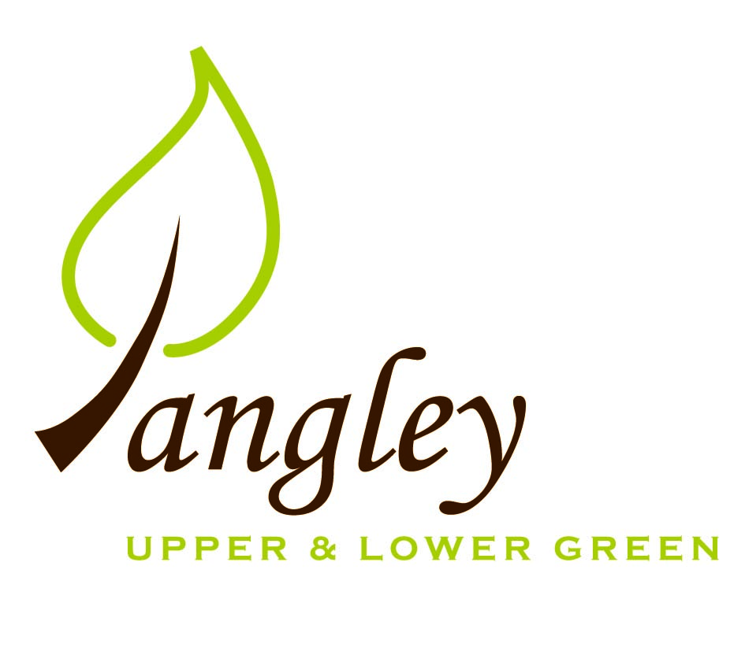

Clerk: Erica Williams
E-mail: langleyclerk@googlemail.com
13 Princes Close, Balsham, Cambridgeshire CB21 4EE

A MEETING OF LANGLEY PARISH COUNCIL
HELD AT LANGLEY COMMUNITY CENTRE ON
MONDAY 8th April 2024 at 8.00pm

MINUTES
Attended: Cllr Elkington (Chair), Cllr North (Vice-Chair), Cllr Smith, Cllr Anderson, Cllr Clark, Cllr George, Cllr Barnes.
Minutes: Erica Williams (Clerk)

1. APOLOGIES FOR ABSENCE
None.

2. DECLARATION OF INTERESTS
It was proposed and agreed by all that Langley Parish Council is the registered owner of the village green and Councillors declare general
interests in all agenda items relating to the village green. Any other interests would be declared in the usual way.
- Cllr Elkington: non-pecuniary, member of the Parish Council that owns the land on which the community centre is built.
- Cllr North: non-pecuniary, member of the Parish Council that owns the land on which the community centre is built.
- Cllr Smith: non-pecuniary, member of the Parish Council that owns the land on which the community centre is built.
- Cllr Anderson: non-pecuniary, member of the Parish Council that owns the land on which the community centre is built.
- Cllr Clark: non-pecuniary, member of the Parish Council that owns the land on which the community centre is built.
- Cllr George: non-pecuniary, member of the Parish Council that owns the land on which the community centre is built.
- Cllr Barnes: non-pecuniary, member of the Parish Council that owns the land on which the community centre is built.

3. PUBLIC PARTICIPATION SESSION WITH RESPECT TO ITEMS ON THE AGENDA AND OTHER MATTERS THAT ARE OF MUTUAL INTEREST
3.1 Two members of the public attended. One parishioner reported that the footpath the runs alongside the park is overgrown with grass. Cllr Anderson to action.

4. MINUTES OF THE LAST MEETING
4.1 Councillors were asked to review the Minutes of the Parish Council meeting held on Monday 11th March. All agreed and Chair signed them off.

5. FINANCIAL CLARIFICATION
5.1 Financial Report – Bank reconciliation as at 31st March, the current account balance was £18,509.80. PC unpresented payments, £4,025.38 resulting in a current account balance of £14,484.42. Broken down as follows: Playground H&S funds £699.37, Ditches funds £2,000.00, Playground funds £3,214.14; PC funds £8,570.91. PC deposit account £10,376.73 (interest received of £70.66).
5.2 All Cllrs reviewed and agreed BACS run.
5.3 Cllr Elkington proposed engaging JK Bookkeeping for Year End Accounts and Taylor Bradshaw for Internal Audit, as in previous years. All agreed.
5.4 Cllrs discussed grant available from Hundred Parishes Society to improve pond at The Causeway. Clerk to speak to The Pond Specialist and Cllr Clark to speak to FWAG regarding quotes before applying for grant funding.

6. PLANNING APPLICATIONS/PROPERTY
6.1 None received.

7. LANGLEY VILLAGE PROJECT
7.1 No updates.

8. LOCAL ENVIRONMENT
8.1 Tree work in Long Ley complete. No further tree works this season but Cllr Smith to prepare a new list for next season, concentrating on areas with high public footfall first.
8.2 Ditch clearance programme – Cllr George has identified areas of blocked drains and ditches along Bull Lane. Underwater pipes need clearing as they are almost full. All locations have been logged on ECC interactive map. Cllr George to provide Clerk with a full list that can be sent to ECC to action.
8.3 Cllr Smith to plant young Oak Tree by the end of April.
8.6 Clerk to investigate costings of portable speed devices and posts. It was agreed that there would need to be 3 posts and 2 devices to service the village. Clerk will then apply for additional funding from the Community Safety Fund.
8.7 Cllr North will consult with residents about the possible parking bay and report back at the next meeting.
8.8 Draft paperwork was reviewed from Rural Affordable Housing. All happy and Clerk to give consent to go ahead with generating letters.
8.10 Cllr Elkington proposed that the PC contribute £200 towards the cost of hiring the Community Centre for the evening of the Beacon lighting (Thursday 6th June) for the International Tribute D-Day, along with hiring costs for the family event on Saturday 8th June. PC to also purchase bunting for the Community Centre. All agreed.

9. PLAYGROUND
9.1 Quote has now been received for the outstanding remedial works, which the PC approved. Cllr North awaiting quote for cutting back the hedge along the field side of the playground.

10. DISTRICT COUNCIL
Cllr Oliver sent his apologies prior to the meeting.

11. BACS PAYMENTS
11.1 Council agreed the following BACS payments to be made:

Langley Parish Council – BACS payments for April 2024
RCCE | Membership renewal | BACS | £44.10
GWB Horticulture | Grass cutting | BACS | £349.86
Crown Tree & Garden Care | Tree surgery | BACS | £3,120.00
Erica Williams | Clerks salary | BACS | £374.63
EALC / NALC | Affiliation fees | BACS | £136.79
 |  | Total | £4,025.38
12. MATTERS TO BE RAISED BY MEMBERS FOR THE NEXT AGENDA
12.1 Cllr training dates
12.2 Community Awards
12.3 Annual Village Meeting to be held on Wednesday 22nd May 2024

13. DATE OF NEXT MEETING:
13.1 The next meeting will be on Monday 13th May 2024 at Langley Community Centre.

