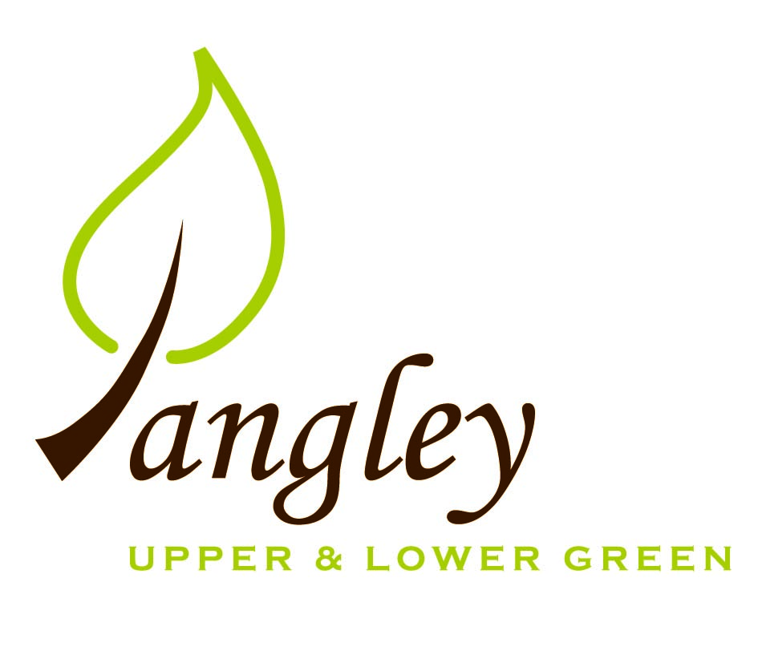

|  |
| --- |
| **Langley Parish Council**  Clerk: Erica Williams  13 Princes Close, Balsham, Cambridge CB21 4EE  07539 249852 langleyclerk@googlemail.com |

NOTICE

DECEMBER 2023 CHEQUE RUN

As in previous years, there is no meeting of the Parish Council during the month of December. Please see below the payment run for this month.

NEXT MEETING: Monday 8th January 2024 at 8.00pm. Held at Langley Community Centre.

|  |  |  |  |
| --- | --- | --- | --- |
| **Langley Parish Council - Payment run for December 2023** | | | |
| Erica Williams | Clerks salary (including back pay award) | BACS | £598.63 |
| Paul Abrahams | Grass cutting | BACS | £100.00 |
| Wicksteed Leisure | Playground inspection | BACS | £158.40 |
| AS Clark & Sons | Christmas Tree for Village Green | BACS | £135.00 |
|  |  |  |  |
|  |  |  |  |
|  |  |  |  |
|  |  |  |  |
|  |  | **Total:** | **£992.03** |