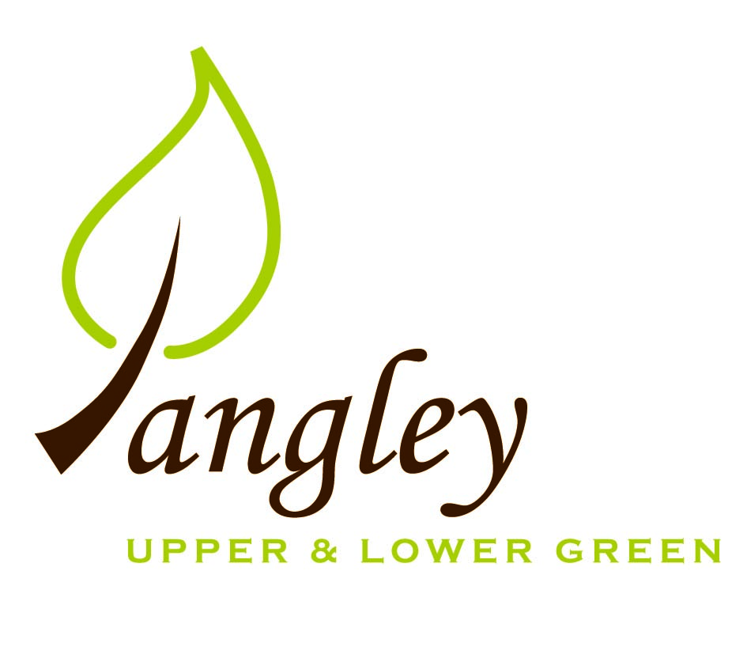

Clerk: Erica Williams
E-mail: langleyclerk@googlemail.com
13 Princes Close, Balsham, Cambridgeshire CB21 4EE

A MEETING OF LANGLEY PARISH COUNCIL
HELD AT LANGLEY COMMUNITY CENTRE ON
MONDAY 13^{h} January 2025 at 8.00pm

MINUTES
Attended: Cllr Elkington (Chair), Cllr North, Cllr Clark, Cllr Smith, Cllr George, Cllr Barnes, Cllr Anderson
Minutes: Erica Williams (Clerk)

1. APOLOGIES FOR ABSENCE
None received.

2. DECLARATION OF INTERESTS
It was proposed and agreed by all that Langley Parish Council is the registered owner of the village green and Councillors declare general
interests in all agenda items relating to the village green. Any other interests would be declared in the usual way.
- Cllr Elkington: non-pecuniary, member of the Parish Council that owns the land on which the community centre is built.
- Cllr North: non-pecuniary, member of the Parish Council that owns the land on which the community centre is built.
- Cllr Clark: non-pecuniary, member of the Parish Council that owns the land on which the community centre is built.
- Cllr Smith: non-pecuniary, member of the Parish Council that owns the land on which the community centre is built.
- Cllr George: non-pecuniary, member of the Parish Council that owns the land on which the community centre is built.
- Cllr Barnes: non-pecuniary, member of the Parish Council that owns the land on which the community centre is built.
- Cllr Anderson: non-pecuniary, member of the Parish Council that owns the land on which the community centre is built.

3. PUBLIC PARTICIPATION SESSION WITH RESPECT TO ITEMS ON THE AGENDA AND OTHER MATTERS THAT ARE OF MUTUAL INTEREST
3.1 One member of the public attended.

4. MINUTES OF THE LAST MEETING
4.1 Councillors were asked to review the Minutes of the Parish Council meeting held on Monday 11th November (no meeting in December). All agreed and Chair signed them off.

5. FINANCIAL CLARIFICATION
5.1 Financial Report – Bank reconciliation as at 31st December, the current account balance was £22,362.69. PC unpresented payments, £2,075.07 resulting in a current account balance of £20,287.62. Broken down as follows: Playground H&S funds £239.37, Ditches funds £2,000.00, Speed sign funds £3,214.14; PC funds £14,834.11. PC deposit account £10,590.75 (Interest received of £70.46).
5.2 All Cllrs reviewed and agreed BACS run.
5.3 Due to the recent website renewal costs, Cllrs decided to opt-in to gov.uk email addresses only. Clerk to update quotes.
5.4 Quote received for noticeboard maintenance of £843. Clerk to obtain two further quotes.
5.5 Precept 2025/6 – Cllrs discussed draft precept. Cllr Elkington asked Cllrs if they were in agreement with the proposals. All agreed for submission to UDC. Clerk to submit.
5.6 Grant request from LCC&ST for £250 towards the repair of lawnmower used to cut around the Village Green. All agreed to award the grant.

6. PLANNING APPLICATIONS/PROPERTY
6.1 UTT/24/3008/CLE – Barn East of The Gables, Langley Upper Green – NO COMMENT

7. LANGLEY VILLAGE PROJECT
7.1 Quotes received for Church flooring and funding being finalised. Community Centre fundraiser pencilled in for March – further details to follow.

8. LOCAL ENVIRONMENT
8.1 The PC have received one tender for grass cutting contract. Deadline extended to end of February and Clerk to chase all interested parties.
8.2 Clerk has notified UK Power Networks about overhanging branches near to power lines in the Lower Green and UK Power Networks to visit. Dead trees by the playground have stump grinded and maintenance carried out on others. Further quotes to be obtained for trees around the Village Green.
8.3 Highways have jetted Bull Lane but some blockages remain. Further meeting has been requested to organise the next phase. The PC have received a quote for £660 plus VAT to clear the drains on Common Land. Cllr Elkington propose the PC accept the quote. Cllr Clark seconded. All agreed.
8.4 Deed of Access requested from resident. Cllr North has requested the deed from PC solicitors which is to be paid at the residents cost. Deed to include a paragraph stating any construction damage caused to the track to be made right by the owner of the plot.
8.5 Permission decision due shortly for the VAS speed signs. Funds almost in place to purchase two devices. Clerk has applied to the Fete Committee for additional funding. Plans in place for third location near to Sparrows.

9. PLAYGROUND
9.1 Inspection report received. To be discussed at next meeting.

10. DISTRICT & COUNTY COUNCIL
Cllr Oliver provided an update to Cllrs and answered questions.

11. BACS PAYMENTS
11.1 Council agreed the following BACS payments to be made:
Langley Parish Council – BACS payments for January 2025
LCC & ST | Community Centre hire | BACS | £100.00
G. Law Agricultural | Verges cutting | BACS | £1300.00
Clavering Parish Council | Green waste collection | BACS | £189.98
Erica Williams | Clerks salary | BACS | £485.09
 |  | Total | £2075.07
Langley Parish Council - BACS payments made in December 2024
Hopkins (Print Juice) | Village Voice printing | BACS | £75.00
Wicksteed Leisure | Playground inspection | BACS | £180.00
Robsons | Christmas Tree for Village Green | BACS | £135.00
Erica Williams | Clerks salary | BACS | £374.27
Erica Williams | Reimbursement for website renewal | BACS | £360.00
 |  | Total | £1124.27

12. MATTERS TO BE RAISED BY MEMBERS FOR THE NEXT AGENDA
12.1 RCCE Low Cost Housing
12.2 Steamwatch
12.3 Website review
12.4 Phone boxes in Upper and Lower Green
12.5 Beacon event

13. DATE OF NEXT MEETING:
13.1 The next meeting will be on Monday 10th February 2025 at Langley Community Centre.

