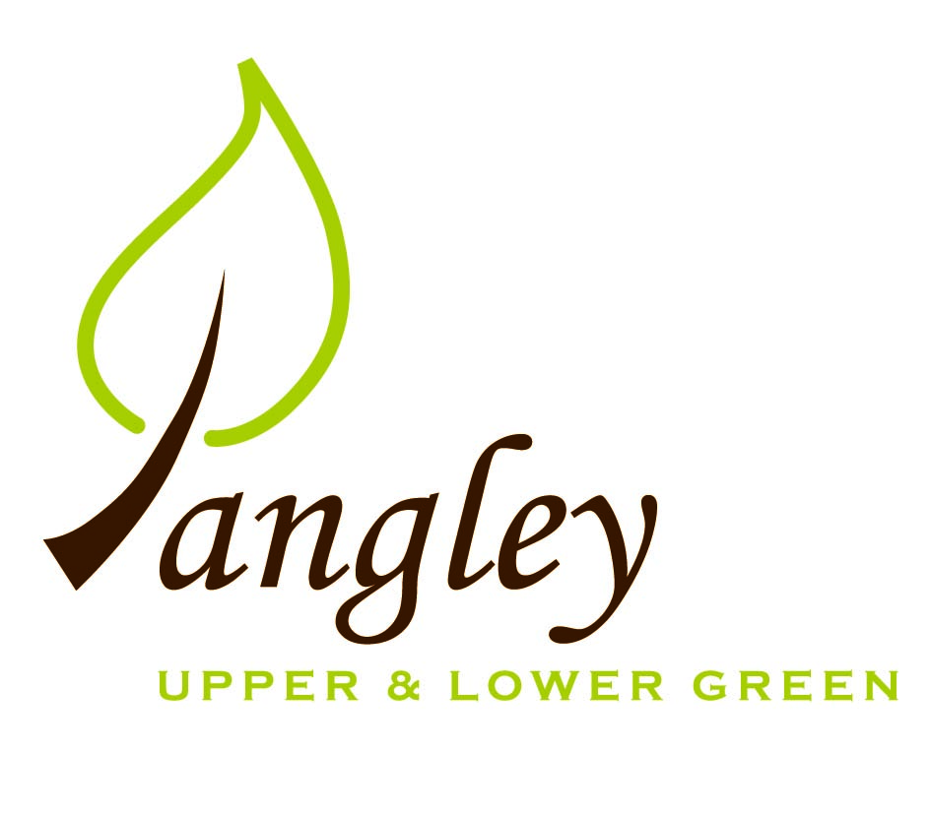

Clerk: Erica Williams
E-mail: langleyclerk@googlemail.com
13 Princes Close, Balsham, Cambridgeshire CB21 4EE

A MEETING OF LANGLEY PARISH COUNCIL
HELD AT LANGLEY COMMUNITY CENTRE ON
MONDAY 11th March 2024 at 8.00pm

MINUTES
Attended: Cllr Elkington (Chair), Cllr North (Vice-Chair), Cllr Smith, Cllr Anderson, Cllr Clark, Cllr George.
Minutes: Erica Williams (Clerk)

1. APOLOGIES FOR ABSENCE
Cllr Barnes.

2. DECLARATION OF INTERESTS
It was proposed and agreed by all that Langley Parish Council is the registered owner of the village green and Councillors declare general
interests in all agenda items relating to the village green. Any other interests would be declared in the usual way.
- Cllr Elkington: non-pecuniary, member of the Parish Council that owns the land on which the community centre is built.
- Cllr North: non-pecuniary, member of the Parish Council that owns the land on which the community centre is built. 6.2: personal, applicant is a close family friend.
- Cllr Smith: non-pecuniary, member of the Parish Council that owns the land on which the community centre is built. 6.3: personal: neighbouring property to proposed site.
- Cllr Anderson: non-pecuniary, member of the Parish Council that owns the land on which the community centre is built.
- Cllr Clark: non-pecuniary, member of the Parish Council that owns the land on which the community centre is built.
- Cllr George: non-pecuniary, member of the Parish Council that owns the land on which the community centre is built.

3. PUBLIC PARTICIPATION SESSION WITH RESPECT TO ITEMS ON THE AGENDA AND OTHER MATTERS THAT ARE OF MUTUAL INTEREST
3.1 Five members of the public attended.

4. MINUTES OF THE LAST MEETING
4.1 Councillors were asked to review the Minutes of the Parish Council meeting held on Monday 12th February. All agreed and Chair signed them off.

5. FINANCIAL CLARIFICATION
5.1 Financial Report – Bank reconciliation as at 29th February, the current account balance was £22,393.04, due to the verges payment received of £1,475.89. PC unpresented payments, £1,274.63 resulting in a current account balance of £21,118.41. Broken down as follows: Playground H&S funds £699.37, Ditches funds £2,000.00, Playground funds £3,214.14; PC funds £15,204.90. PC deposit account £10,306.07.
5.2 All Cllrs reviewed and agreed BACS run.
5.3 Cllr North updated PC on Deed of Grant process, which is complex. Cllrs agreed that the PC will no longer insist on Deed of Access for homeowners around the village generally, but will insist on properties around the Village Green applying for one, with the homeowner meeting the legal costs.
5.4 Clerk presented quotes for a new picnic bench on the Village Green. Approval given for wooden A-frame bench at a maximum cost of £360.00.

6. PLANNING APPLICATIONS/PROPERTY
6.1 UTT/24/0116/FUL – The Bull, Langley Lower Green – PC wish to seek clarity on access to Bull Lane and proposed visibility splays, along with clarity on ownership of proposed site due to a discrepancy in the site size. PC would also like to highlight how difficult this application has been to navigate, with numerous changes and errors in the submitted documents.
6.2 UTT/24/0497/FUL – Land North of Broad Halfpenny, Langley Upper Green – No comment.
6.3 UTT/24/0359/FUL – Land rear of Sparrows, Langley Upper Green – PC wish to echo comments made by parishioner about the development being on open farmland and outside of the village boundary, creating a secondary level of development. Further concerns about increased traffic, insufficient access to Sparrows, degradation of road surface and over-sized dwellings.

7. LANGLEY VILLAGE PROJECT
7.1 No updates.

8. LOCAL ENVIRONMENT
8.1 Crown Tree & Garden Care to carry out tree works in Long Ley on 25th and 26th March.
8.2 Ditch clearance programme to be reviewed by Cllr George with a new programme of works based on priority to areas prone to flooding
and further research undertaken. Cllrs agreed to concentrate resources on the Lower Green at the moment as water can be directed into the river. Ditches are currently too full of water to proceed with any clearance works. Clerk to request assistance from Cllr Gadd.
8.3 Cllrs Elkington and Smith have selected tree from Ken Rivett, who will be supplying a commemorative plaque. Cllr Smith to plant.
8.4 See 8.2.
8.5 See 8.2.
8.6 Correspondance received from Cllr Gadd suggests that Highways will not support traffic calming measures. PC to explore the possibility of purchasing portable flashing speed signs. Clerk to review costs. Cllr Elkington suggested signage into Upper Green stating ‘no footpath’ and Clerk to liaise with Highways about installation process. A member of the public kindly offered to look into Community Speedwatch.
8.7 Cllr North has carried out extensive investigation into the creation of a parking bay but it is complex due to being on Common Land. Ongoing.
8.8 Clerk awaiting draft paperwork from Rural Affordable Housing.
8.9 At the February meeting, Cllrs discussed the request to adopt a new scythe mower on behalf of the community. After discussion it was agreed that the PC did not wish to undertake responsibility and liability for machinery used by residents.
8.10 International Tribute – D Day. Beacon event on the Village Green on 6th June and family event on 8th June. Cllr Elkington requested permission to use the Village Green for both events and Cllrs agreed. Cllr North to notify the police of plans and Clerk to speak to insurers. Cllr Elkington to put costs to the PC in due course.

9. PLAYGROUND
9.1 Awaiting quote for remaining safety works. Cllr North to request hedge cutting work from Paul Abrahams.

10. DISTRICT COUNCIL
Cllr Oliver sent his apologies and distributed his report to Cllrs prior to the meeting.

11. BACS PAYMENTS
11.1 Council agreed the following BACS payments to be made:

Langley Parish Council – BACS payments for March 2024
RAS Handyman Services | New fencing at the playground (already paid) | BACS | £618.00
Friends of Clavering School | Grant | BACS | £500.00
Paul Abrahams | Tree surgery | BACS | £400.00
Erica Williams | Clerks salary | BACS | £374.63
 |  | Total | £1892.63
12. MATTERS TO BE RAISED BY MEMBERS FOR THE NEXT AGENDA

13. DATE OF NEXT MEETING:
13.1 The next meeting will be on Monday 8th April 2024 at Langley Community Centre.

