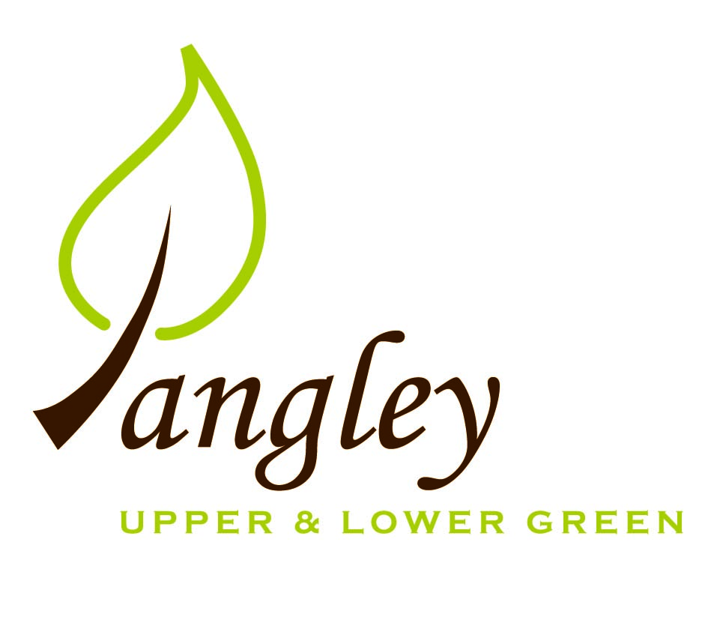

Clerk: Erica Williams
E-mail: langleyclerk@googlemail.com
13 Princes Close, Balsham, Cambridgeshire CB21 4EE

A MEETING OF LANGLEY PARISH COUNCIL
HELD AT LANGLEY COMMUNITY CENTRE ON
MONDAY 12th February 2024 at 8.00pm

MINUTES
Attended: Cllr Elkington (Chair), Cllr North (Vice-Chair), Cllr Smith, Cllr Anderson, Cllr Barnes, Cllr Clark, Melanie George. Cllr Oliver (UDC) arrived at 8.40pm
Minutes: Cllr Elkington

1. APOLOGIES FOR ABSENCE

2. DECLARATION OF INTERESTS
It was proposed and agreed by all that Langley Parish Council is the registered owner of the village green and Councillors declare general
interests in all agenda items relating to the village green. Any other interests would be declared in the usual way.
- Cllr Elkington: non-pecuniary, member of the Parish Council that owns the land on which the community centre is built.
- Cllr North: non-pecuniary, member of the Parish Council that owns the land on which the community centre is built.
- Cllr Smith: non-pecuniary, member of the Parish Council that owns the land on which the community centre is built.
- Cllr Barnes: non-pecuniary, member of the Parish Council that owns the land on which the community centre is built.
- Cllr Anderson: non-pecuniary, member of the Parish Council that owns the land on which the community centre is built. 6.1 Pecuniary interest – applicant.
- Cllr Clark: non-pecuniary, member of the Parish Council that owns the land on which the community centre is built. 6.1 Personal interest – application is an employee.
- Cllr George: non-pecuniary, member of the Parish Council that owns the land on which the community centre is built.

3. PUBLIC PARTICIPATION SESSION WITH RESPECT TO ITEMS ON THE AGENDA AND OTHER MATTERS THAT ARE OF MUTUAL INTEREST
3.1 Two members of the public attended.

4. MINUTES OF THE LAST MEETING
4.1 Councillors were asked to review the Minutes of the Parish Council meeting held on Monday 8th January. All agreed and Chair signed them off.

5. FINANCIAL CLARIFICATION
5.1 Financial Report – Bank reconciliation as at 30th January, the current account balance was £22,411.77, due to VAT reclaim received of £1,031.09. PC unpresented payments, £808.04 resulting in a current account balance of £21,603.73. Broken down as follows: Playground H&S funds £1,317.37, Ditches funds £2,000.00, Playground funds £3,214.14; PC funds £15,072.22. PC deposit account £10,306.07.
5.2 All Cllrs reviewed and agreed BACS run.
5.3 Clerk has received dates for New Councillor training and will book sessions for Cllrs Smith, George and Anderson.
5.4 Following a request from Friends of Clavering Primary School, the PC agreed to make a donation. Cllr Smith proposed £500.00, Cllr George seconded. All agreed.
5.5 Clerk to order replacement defibrillator pads for the Upper Green defibrillator.

6. PLANNING APPLICATIONS/PROPERTY
6.1 UTT/24/0214/HHF – 8 Long Ley, Langley Upper Green – NO OBJECTIONS
6.2 UTT/24/0116/FUL – The Bull, Langley Lower Green
The PC discussed this in three parts:
1) Nissen Hut conversion – NO OBJECTIONS
2) Garages & private parking to Bull Lane side – NO OBJECTIONS
3) New parking spaces for the Bull PH and creation of in/out driveway – THE LAND PROPOSED FOR THE CREATION OF PARKING BAYS TO THE BULL IS NOT IN THE OWNERSHIP OF THE BULL AND IS REGISTERED COMMON LAND. THE PC REFUSES CONSENT FOR THIS. THE PC ALSO STRONGLY OBJECTIONS TO THE CREATION OF IN/OUT DRIVEWAY AT A PREVIOUSLY BLOCKED LOCATION DUE TO SAFETY REASONS
6.3 UTT/24/0036/HHF – Herons Rest, Langley Upper Green – NO OBJECTIONS

7. LANGLEY VILLAGE PROJECT
7.1 Waiting for Giant’s Table (wooden free-standing internal platform for the Church tower) to be built. Work ongoing.

8. LOCAL ENVIRONMENT
8.1 Clerk received two quotes for tree work in Long Ley. PC to accept quote from Crown Tree & Garden Care for £3,120.00. Clerk to instruct. Tree work at Ashwater to commence shortly at price of £400.00.
8.2 Due to flooding and saturated ground ditch clearance will have to wait for dryer weather.
8.3 Cllrs Smith and Elkington to arrange meeting with Ken Rivett regarding young Oak tree.
8.4 Potholes in Long Ley. Uttlesford Norse have confirmed that Long Ley resurfacing is a priority and will commence consultation with residents shortly.
8.5 Possible parking bay. PC have requested meeting with solicitors to understand legalities involved.
8.6 Affordable Housing: Clerk received quote for survey process from Rural Affordable Housing. The PC wish to proceed to the next stage and Clerk to instruct.
8.7 Residents Committee have met regarding the track around the Village Green and work to repair the surface will hopefully commence at the end of the month. Water connections at the edge of the track must remain accessible. PC to incorporate making good of new surface following building work into any future deeds of access granted.
8.8 Following the purchase of a new mower by a resident, PC to remove old mower from asset list.
8.9 D-Day Beacon event will take place on 6th June at 9.15pm, followed by a family event on Saturday 8th June. Further details to follow.

9. PLAYGROUND
9.1 Cllr North met Playground maintenance contractor on site. Fencing works will commence shortly and the PC awaits a quote for the remaining maintenance works.

10. DISTRICT COUNCIL
Cllr Oliver gave an update and answered questions on this from Cllrs.

11. BACS PAYMENTS
11.1 Council agreed the following BACS payments to be made:

Langley Parish Council – BACS payments for February 2024
Erica Williams | Clerks salary | BACS | £463.04
GWB Horticulture | Grass cuttings collection | BACS | £300.00
Open Spaces Society | Membership renewal | BACS | £45.00
 |  | Total | £808.04
12. MATTERS TO BE RAISED BY MEMBERS FOR THE NEXT AGENDA
River maintenance and potential flooding
Roads in Lower Green
Highways – traffic calming and signage

13. DATE OF NEXT MEETING:
13.1 The next meeting will be on Monday 11th March 2024 at Langley Community Centre.

