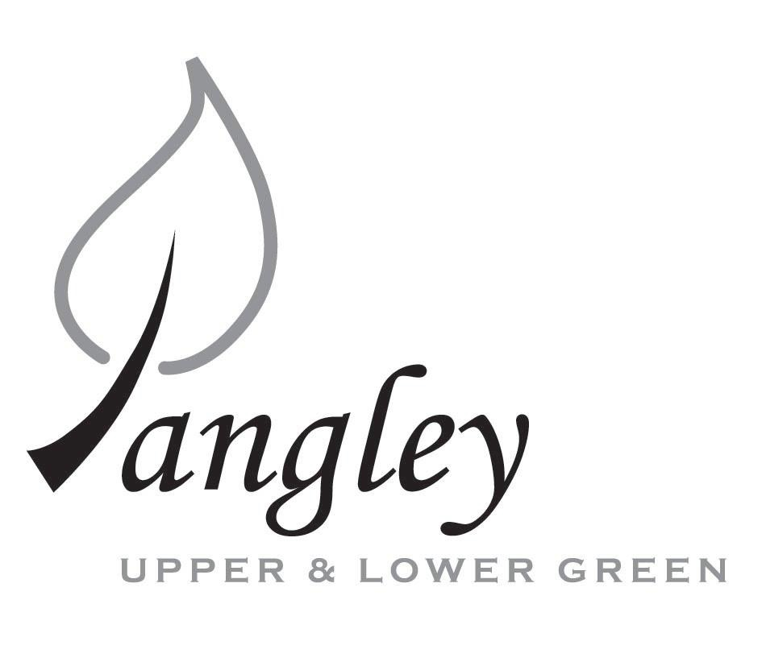

|  |
| --- |
| 13 Princes Close, Balsham, Cambridgeshire CB21 4EE  E-mail: [langleyclerk@googlemail.com](mailto:langleyclerk@googlemail.com)  Telephone: 07539 249852  COUNCILLORS ARE SUMMONED TO ATTENDA MEETING OF LANGLEY PARISH COUNCIL  HELD AT LANGLEY COMMUNITY CENTRE ON  **Monday 13th January 2025 at 8.00pm**  *THE PRESS AND THE PUBLIC ARE CORDIALLY INVITED TO ATTEND* |

**This Parish Council supports the rights of anyone to record this meeting but advises that anyone so recording cannot disrupt the meeting, by means of the recording and expresses the hope that the person (or persons) carrying out the recording has obtained the necessary legal advice, for themselves, to ensure they understand the rights of any members of the public who may be present who do not wish to be filmed or recorded.**

**1. APOLOGIES FOR ABSENCE**

1.1 To receive apologies for absence.

**2. DECLARATION OF INTERESTS**

2.1 To declare any disclosable pecuniary, other pecuniary or non-pecuniary interests relating to items on the agenda.

**3.** **PUBLIC PARTICIPATION SESSION WITH RESPECT TO ITEMS ON THE AGENDA AND OTHER MATTERS THAT ARE OF MUTUAL INTEREST**

3.1 The maximum time allowed for this item is 15 minutes. Members of the public who wish to comment on an Agenda item should do so at this point – maximum time allowed 5 minutes per Agenda item. Any questions raised shall not require a response at the meeting nor start a debate on the question. The Chair of the meeting may direct that a written or oral response be given.

**4.** **MINUTES OF THE LAST MEETING**

4.1 Councillors are asked to agree the Minutes of the Parish Council meeting held on Monday 11th November 2024, as a true and accurate account of the proceedings of the meetings.

**5.** **FINANCIAL**

5.1 **Financial Report** – Bank reconciliation as at 31st December, the current account balance was £22,362.69. PC unpresented payments, £2,075.07 resulting in a current account balance of £20,287.62. Broken down as follows: Playground H&S funds £239.37, Ditches funds £2,000.00, Speed sign funds £3,214.14; PC funds £14,834.11. PC deposit account £10,590.75 (Interest received of £70.46).

5.2 Review of BACS payments.

5.3 Gov.uk email addresses for Councillors.

5.4 Quote for noticeboard maintenance

5.5 Precept 2025/26

5.6 Grant request from LCC & ST

**6. PLANNING APPLICATIONS/PROPERTY**

6.1 UTT/24/3008/CLE – Barn East of The Gables, Langley Upper Green

**7.** **LANGLEY VILLAGE PROJECT**

7.1 Brief update from Village Project representatives.

**8. LOCAL ENVIRONMENT**

8.1 Grass cutting schedule and new tender, to include presentation on robot mower from Cllr Smith

8.2 Tree works update

8.3 Update on revised ditch clearance programme and flooding

8.4 Deed of Access request

8.5 Flashing speed signs update

**9. PLAYGROUND**

9.1 Inspection report findings

**10.** **DISTRICT AND COUNTY COUNCIL**

10.1 Cllr. Oliver to provide District Council report.

**11. BACS PAYMENTS**

11.1 Council to agree to the following BACS payments to be made:

|  |  |  |  |
| --- | --- | --- | --- |
| **Langley Parish Council – BACS payments for January 2025** | | | |
| LCC & ST | Community Centre hire | BACS | £100.00 |
| G. Law Agricultural | Verges cutting | BACS | £1300.00 |
| Clavering Parish Council | Green waste collection | BACS | £189.98 |
| Erica Williams | Clerks salary | BACS | £485.09 |
|  |  | Total | **£2075.07** |
| **Langley Parish Council - BACS payments made in December 2024** | | | |
| Hopkins (Print Juice) | Village Voice printing | BACS | £75.00 |
| Wicksteed Leisure | Playground inspection | BACS | £180.00 |
| Robsons | Christmas Tree for Village Green | BACS | £135.00 |
| Erica Williams | Clerks salary | BACS | £374.27 |
| Erica Williams | Reimbursement for website renewal | BACS | £360.00 |
|  |  | Total | **£1124.27** |

**12. MATTERS TO BE RAISED BY MEMBERS FOR THE NEXT AGENDA**

12.1 Please note that no decisions can lawfully be made under this item. LGA 1972, Section 12 10(2)(b) states that business must be specified; therefore, the Council cannot lawfully raise matters for decision.

**13. DATE OF NEXT MEETINGS**

13.1 The next meeting will be on Monday 10th February 2025 at Langley Community Centre.

|  |  |
| --- | --- |
| **SIGNED (CLERK):** | **DATE:** |