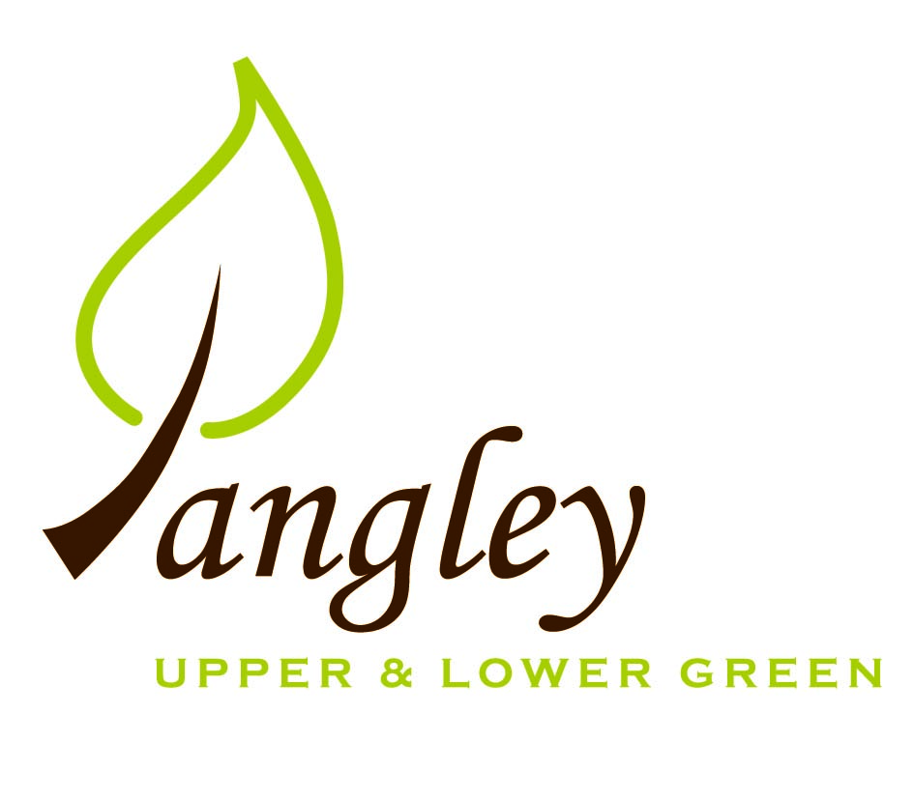

Clerk: Erica Williams
E-mail: langleyclerk@googlemail.com
13 Princes Close, Balsham, Cambridgeshire CB21 4EE

A MEETING OF LANGLEY PARISH COUNCIL
HELD AT LANGLEY COMMUNITY CENTRE ON
MONDAY 9th January 2023 at 8.00pm

MINUTES
Attended: Cllr Elkington (Chair), Cllr North (Vice-Chairman), Cllr Bull, Cllr Barnes, Cllr Smith; Cllr Edward Oliver (UDC), arrived at 8.35pm.
Minutes: Erica Williams (Clerk)

1. APOLOGIES FOR ABSENCE
Cllr Clark, Cllr Joplin

2. DECLARATION OF INTERESTS
It was proposed and agreed by all that Langley Parish Council is the registered owner of the village green and Councillors declare general
interests in all agenda items relating to the village green. Any other interests would be declared in the usual way.
- Cllr Elkington: 8.1, non-pecuniary, member of the Parish Council that owns the land on which the community centre is built.
- Cllr North: 8.1, non-pecuniary, member of the Parish Council that owns the land on which the community centre is built.
- Cllr Bull: 8.1, non-pecuniary, member of the Parish Council that owns the land on which the community centre is built.
- Cllr Smith: 8.1, non-pecuniary, member of the Parish Council that owns the land on which the community centre is built.
- Cllr Barnes: 8.1, non-pecuniary, member of the Parish Council that owns the land on which the community centre is built, 10.8, personal (neighbouring property)

3. PUBLIC PARTICIPATION SESSION WITH RESPECT TO ITEMS ON THE AGENDA AND OTHER MATTERS THAT ARE OF MUTUAL INTEREST
3.1 No members of the public attended.

4. MINUTES OF THE LAST MEETING
4.1 Councillors were asked to review the Minutes of the Parish Council meeting held on Monday 14th November. All agreed and Chair signed them off.

6. FINANCIAL CLARIFICATION
6.1 Financial Report – Bank reconciliation as at 31st December, the current account balance was £17,717.98. PC unpresented payments, £864.64 resulting in a current account balance of £16,853.34. Broken down as follows: Playground funds £1,050.70; PC funds £15,802.64. PC deposit account £10,029.42.
6.2 All Cllrs reviewed and agreed BACS run.
6.3 Cllrs reviewed and agreed the 2023/34 draft precept. Clerk to submit to UDC.

7. PLANNING APPLICATIONS/PROPERTY
7.1 Decisions:
UTT/22/2408/FUL – Barn east of Gables, Upper Green (revised scheme to UTT/21/3129/FUL) – APPROVE
UTT/22/2506/FUL – Barn east of Gables, Upper Green – APPROVE
UTT/22/2668/FUL – Duddenhoe Grange, Upper Green Road – AWAIT ING DECISION
UTT/22/2502/FUL Land At Bull Lane Langley – AWAITING DECISION
7.2 Applications:
UTT/22/3252/HHF – Nats Cottage, Upper Green Road – NO OBJECTIONS
7.3 Cllrs reviewed and discussed reply to planning concerns raised by PC to UDC planning department.

8. LANGLEY VILLAGE PROJECT
8.1 No update.

10. LOCAL ENVIRONMENT
10.1 Trees / Verges / Grass cutting – Cllr Smith provided the PC with a map showing all the TPO trees in the village. Cllrs to meet with Gary Law to confirm tree and ditch work required. Cllr Clark to assist in removal of spoil from any ditch work.
10.2 A resident has confirmed that overhanging branches on their property as you enter the village from Duddenhoe End will be cut in February.
10.3 Lack of Community Centre parking options discussed and thoughts ongoing.
10.4 Cllr Bull presented plan showing approved marquee size in relation to the community centre. Clerk to send to CC committee for inclusion in standard hiring terms.
10.5 Ongoing – request for police representative to attend PC meeting.
10.6 Community Awards Scheme. Cllr Joplin provided the PC with ideas and discussions are ongoing.
10.7 Cllr Elkington to attend Local Elections briefing and report back to PC.
10.8 Cllrs Elkington and North to meet with representative from Methodist Church to discuss possible transfer of lease for the Methodist Church Burial Ground to the PC.
10.9 Cllr North working to try and secure gritters to come through the village as criteria has changed. Further updates to follow.
10.10 Clerk to find out more possible storage options for PC files.
10.11 Funding for Highways Rangers has been stopped and they will cease to be in operation from 1st April 2023.
10.12 Paperwork circulated to Cllrs regarding Assets of Community Value for review and discussion at next PC meeting.

11. PLAYGROUND
11.1 Clerk confirmed that Locality Fund grant via Cllr Paul Gadd has been approved for £1000. Cllr Oliver informed PC that he has also secured a grant for £1000 to be spent on new playground equipment. The PC wish to thank both Cllrs Gadd and Oliver.
Cllr North secured discounted monkey bars as compensation from Sovereign and these will be installed in due course.

12. DISTRICT AND COUNTY COUNCIL
Cllr Gadd circulated his report prior to the meeting and Cllr Oliver provided an update and answered questions from Cllrs.

13. CHEQUES FOR SIGNING
13.1 Council agreed the following BACS payments to be made:

Langley Parish Council – BACS payments for January 2023
LCC & ST | Hire of community centre for PC meetings |  | £132.00
Erica Williams | Clerks salary |  | £343.64
 |  | Total | £475.64
14. MATTERS TO BE RAISED BY MEMBERS FOR THE NEXT AGENDA
14.1 Please note that no decisions can lawfully be made under this item. LGA 1972, Section 12 10(2)(b) states that business must be specified; therefore, the Council cannot lawfully raise matters for decision.

15. DATE OF NEXT MEETING:
15.1 The next meeting will be on Monday 13th February 2023 in Langley Community Centre.

