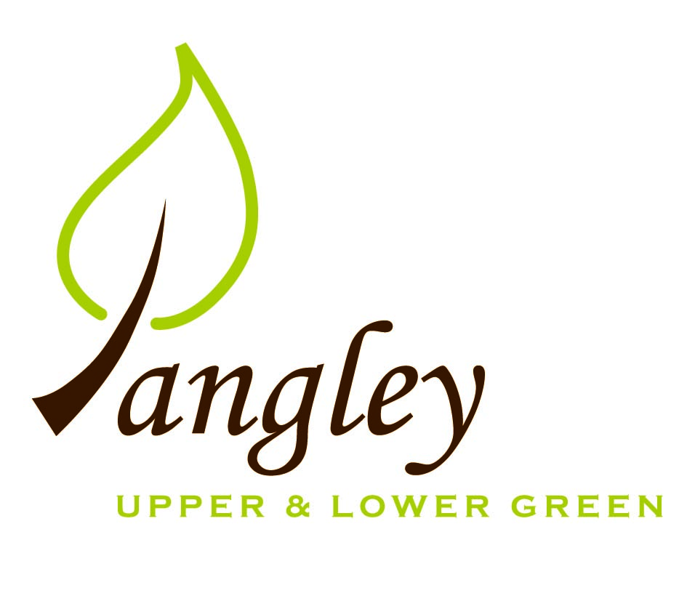

Clerk: Erica Williams
E-mail: langleyclerk@googlemail.com
13 Princes Close, Balsham, Cambridgeshire CB21 4EE

A MEETING OF LANGLEY PARISH COUNCIL
HELD AT LANGLEY COMMUNITY CENTRE ON
MONDAY 14^{h} October 2024 at 8.00pm

MINUTES
Attended: Cllr Elkington (Chair), Cllr Clark, Cllr George, Cllr Barnes
Minutes: Erica Williams (Clerk)

1. APOLOGIES FOR ABSENCE
Cllr North, Cllr Smith, Cllr Anderson

2. DECLARATION OF INTERESTS
It was proposed and agreed by all that Langley Parish Council is the registered owner of the village green and Councillors declare general
interests in all agenda items relating to the village green. Any other interests would be declared in the usual way.
- Cllr Elkington: non-pecuniary, member of the Parish Council that owns the land on which the community centre is built.
- Cllr Clark: non-pecuniary, member of the Parish Council that owns the land on which the community centre is built.
- Cllr George: non-pecuniary, member of the Parish Council that owns the land on which the community centre is built.
- Cllr Barnes: non-pecuniary, member of the Parish Council that owns the land on which the community centre is built.

3. PUBLIC PARTICIPATION SESSION WITH RESPECT TO ITEMS ON THE AGENDA AND OTHER MATTERS THAT ARE OF MUTUAL INTEREST
3.1 No members of the public attended.

4. MINUTES OF THE LAST MEETING
4.1 Councillors were asked to review the Minutes of the Parish Council meeting held on Monday 9th September. All agreed and Chair signed them off.

5. FINANCIAL CLARIFICATION
5.1 Financial Report – Bank reconciliation as at 30th September, the current account balance was £24,465.70 (2nd precept payment received of £8,500.00). PC unpresented payments, £507.14 resulting in a current account balance of £23,958.56. Broken down as follows: Playground H&S funds £239.37, Ditches funds £2,000.00, Speed sign funds £3,214.14; PC funds £18,505.05. PC deposit account £10,520.29 (interest received of £72.42).
5.2 All Cllrs reviewed and agreed BACS run.
5.3 Gov.uk email addresses – further information has been requested and details from registrars who administer the change.
5.4 Clerk to send invoice when laptop has been chosen and Cllrs will approve the payment.
5.5 Scythe Mower – the PC agree to cover service costs and associated VAT, but not repair costs as the mower is not a Parish Council asset.
5.6 Clerk to apply for Locality Fund grant of £500, a grant from Cllr Oliver and apply to the fete committee for a grant to put towards speed signs.

6. PLANNING APPLICATIONS/PROPERTY
6.1 None received.

7. LANGLEY VILLAGE PROJECT
7.1 No update.

8. LOCAL ENVIRONMENT
8.1 Grass cutting contract expires in March 2025. Clerk to send tender package out detailing that the Village Green needs to be cut by a cylinder mower. Deadline of Monday 6th January 2025.
8.2 Cllr Smith to devise simple monitoring system of trees in order to ensure they are maintained. Cllr George to chase Crown Tree & Garden Care for completion of outstanding tree works. UK Power Networks still to carry out tree work on the willow tree outside Lilac Cottage.
8.3 Cllr George has put together a letter to go to landowners regarding ditch clearance. One location is on Common Land – Cllr George to gets quotes for clearance and removal of spoil. Further request for Highways to visit the area around Potterills railings where this is a blocked drain. Drains in Bull Lane are being jetted in November. Cllr Clark has measured the depth gauge at the ford and it is only 4 inches out. Cllrs are happy with the gauge. Clerk to put a request in to Highways for a new ‘Ford’ sign as you approach from the direction of The Bull.
8.4 Communication received from Essex County Council to join the Stream Watch programme. Clerk to request a place on the programme for Cllrs George and Smith.
8.4 Clerk received quote from Elan City for two radar speed signs of £5014.78. Cllrs discussed reservations around the maintenance and moving of speed signs and the possible risks associated with this. Cllr Elkington proposed a quote for solar powered devices that are in a fixed location, for safety reasons. Cllr Clark seconded. Clerk to action.
8.5 Contractor to inspect noticeboards next week and provide PC with a quote for refurbishment.
8.6 Conversations still ongoing with UK Power Networks. Clerk to write to CEO of UK Power Networks.
8.7 Clerk to begin updating PC website.

10. DISTRICT & COUNTY COUNCIL
Cllrs Oliver provided an update to Cllrs and answered questions.

11. BACS PAYMENTS
11.1 Council agreed the following BACS payments to be made:

Langley Parish Council – BACS payments for October 2024
RCCE | Membership renewal | BACS | £44.10
Erica Williams | Clerks salary | BACS | £463.04
 |  | Total | £507.14
12. MATTERS TO BE RAISED BY MEMBERS FOR THE NEXT AGENDA
12.1 Christmas Tree on the Green
12.2 RCCE Low Cost Housing
12.3 Bus service update

13. DATE OF NEXT MEETING:
13.1 The next meeting will be on Monday 11th November 2024 at Langley Community Centre.

