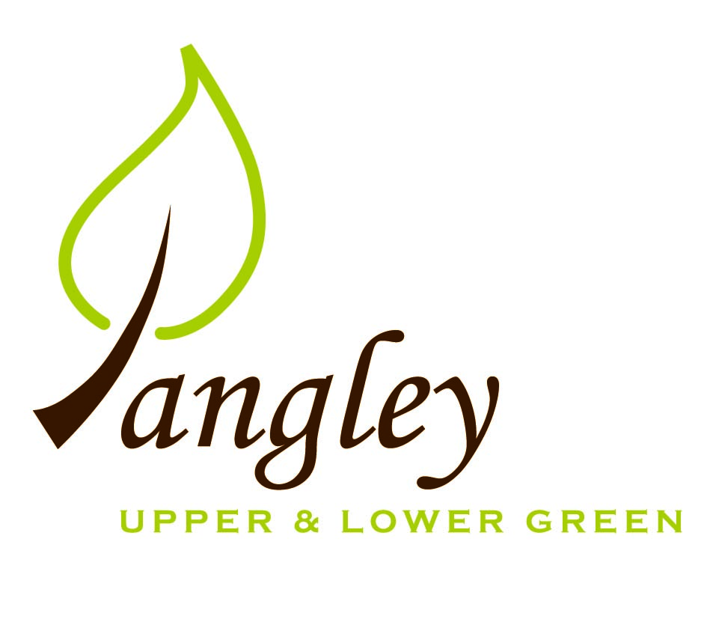

Clerk: Erica Williams
E-mail: langleyclerk@googlemail.com
13 Princes Close, Balsham, Cambridgeshire CB21 4EE

A MEETING OF LANGLEY PARISH COUNCIL
HELD AT LANGLEY COMMUNITY CENTRE ON
MONDAY 13th February 2023 at 8.00pm

MINUTES
Attended: Cllr Elkington (Chair), Cllr Clark, Cllr Joplin, Cllr Barnes, Cllr Smith; Cllr Edward Oliver (UDC), arrived at 8.40pm.
Minutes: Erica Williams (Clerk)

1. APOLOGIES FOR ABSENCE
Cllr Bull, Cllr North.

2. DECLARATION OF INTERESTS
It was proposed and agreed by all that Langley Parish Council is the registered owner of the village green and Councillors declare general
interests in all agenda items relating to the village green. Any other interests would be declared in the usual way.
- Cllr Elkington: 8.1, non-pecuniary, member of the Parish Council that owns the land on which the community centre is built.
- Cllr Clark: 8.1, non-pecuniary, member of the Parish Council that owns the land on which the community centre is built.
- Cllr Joplin: 8.1, non-pecuniary, member of the Parish Council that owns the land on which the community centre is built.
- Cllr Smith: 8.1, non-pecuniary, member of the Parish Council that owns the land on which the community centre is built.
- Cllr Barnes: 8.1, non-pecuniary, member of the Parish Council that owns the land on which the community centre is built,

3. PUBLIC PARTICIPATION SESSION WITH RESPECT TO ITEMS ON THE AGENDA AND OTHER MATTERS THAT ARE OF MUTUAL INTEREST
3.1 No members of the public attended.

4. MINUTES OF THE LAST MEETING
4.1 Councillors were asked to review the Minutes of the Parish Council meeting held on Monday 9th January. All agreed and Chair signed them off.

6. FINANCIAL CLARIFICATION
6.1 Financial Report – Bank reconciliation as at 31st January, the current account balance was £17,285.41. PC unpresented payments, £2,682.51 resulting in a current account balance of £14,602.90. Broken down as follows: Playground funds £1,050.70; PC funds £13,552.20. PC deposit account £10,029.42.
6.2 All Cllrs reviewed and agreed BACS run.
6.3 Cllr Initiative Grant of £1000 received from Cllr Oliver, to be spent on playground equipment. Clerk completing paperwork.
6.4 Confirmation received of £500 grant from the Fete Committee, to be spent on playground equipment, for which the PC would like to thank the Fete Committee.

7. PLANNING APPLICATIONS/PROPERTY
7.1 Decisions:
UTT/22/2668/FUL – Duddenhoe Grange, Upper Green Road – AWAIT ING DECISION
UTT/22/2502/FUL Land At Bull Lane Langley – AWAITING DECISION
UTT/22/3252/HHF – Nats Cottage, Upper Green Road - APPROVE
7.2 Applications:
UTT/23/0077/HHF – 1 The Kangels, Langley Upper Green – NO OBJECTIONS

8. LANGLEY VILLAGE PROJECT
8.1 No update.

10. LOCAL ENVIRONMENT
10.1 Trees / Verges / Grass cutting – Cllrs Smith, Elkington and North met with Gary Law to inspect trees and verges in the village. The PC discussed the need to uplift some trees along the verges for safety reasons and to prevent damage to machinery. Gary Law to provide this service for £300 per day, at a maximum of two days. All Cllrs agreed to this. Clerk to write to Mr Law to confirm.
The PC have requested a further quote from Gary Law for the next phase of ditch clearance, estimated to commence in September. Tree work at The Spinney now complete and a further quote is sought for the removal of a dead ash tree in The Kangels.
10.2 UCD providing grant of £700 towards Coronation events. Plans ongoing for an event on Sunday 7th May.
10.3 Community Awards – further update to follow.
10.4 Cllr Elkington attending Elections training webinar.
10.5 Following an approach from the Methodist Church, Cllrs discussed the request to take on the closed Methodist Church burial ground. Question posed to Cllrs: Does the Parish Council wish to take over the Ownership, maintenance and ongoing financial responsibility for the closed Methodist Graveyard in Langley Lower Green? Unanimous decision to reject the proposal. Clerk to write to the Methodist Church.
10.6 PC storage ongoing. Further updates to follow.
10.7 After discussion, Cllrs voted not to re-nominate The Bull PH for inclusion on the Asset of Community Value register as UDC nomination criteria has changed substantially from previous inclusion.
10.8 Following a request from the new owners of 1, The Kangels, the PC approve the cutting of brambles beyond the fence line to a distance of 1metre.

11. PLAYGROUND
11.1 Monkey bars have now been ordered and a new location suggested. The PC await installation date. Quote requested for the removal of goal post. Sign to be installed reminded residents that dogs are not permitted in the playground. Clerk to speak to Wicksteed and Sovereign regarding the completion of outstanding maintenance work. Cllrs to meet at the playground to discuss and plan the next stage of works.

12. DISTRICT AND COUNTY COUNCIL
Cllr Oliver provided an update and answered questions from Cllrs.

13. CHEQUES FOR SIGNING
13.1 Council agreed the following BACS payments to be made:

Langley Parish Council – BACS payments for February 2023
Essex & Herts Air Ambulance | Donation approved in January meeting (paid in January BACS run) |  | £150.00
Erica Williams | Reimbursement for purchase of printer (paid in January BACS run) |  | £60.00
Sovereign Design Ltd | Deposit for new playground equipment |  | £363.46
SLCC | Membership renewal |  | £101.00
Gareth Law | Verge cutting |  | £1,350.00
Erica Williams | Clerks salary |  | £425.05
EALC | Elections briefing training session |  | £54.00
 |  | Total | £2,293.51
14. MATTERS TO BE RAISED BY MEMBERS FOR THE NEXT AGENDA
14.1 Please note that no decisions can lawfully be made under this item. LGA 1972, Section 12 10(2)(b) states that business must be specified; therefore, the Council cannot lawfully raise matters for decision.

15. DATE OF NEXT MEETING:
15.1 The next meeting will be on Monday 13th March 2023 at Langley Community Centre.

