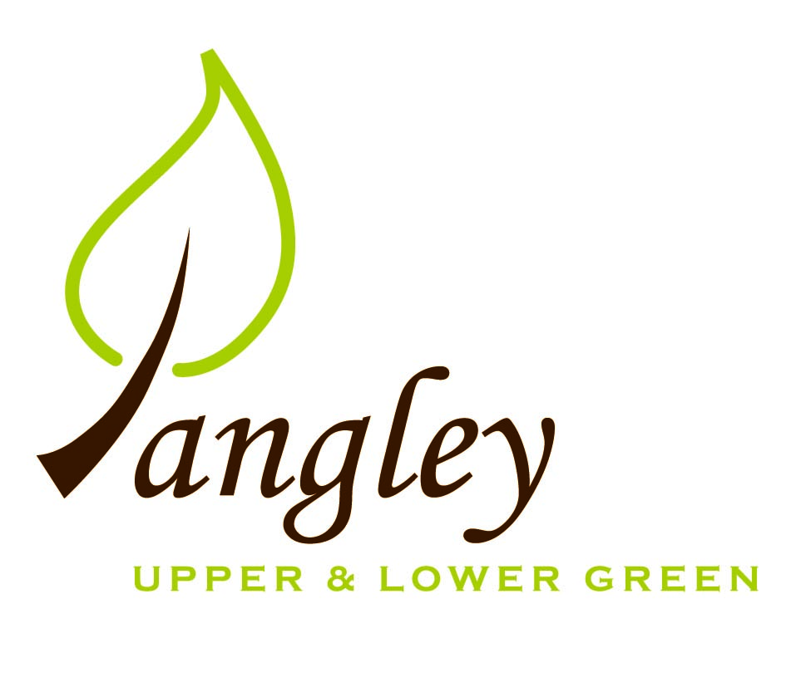

Clerk: Erica Williams
E-mail: langleyclerk@googlemail.com
13 Princes Close, Balsham, Cambridgeshire CB21 4EE

A MEETING OF LANGLEY PARISH COUNCIL
HELD AT LANGLEY COMMUNITY CENTRE ON
MONDAY 13th March 2023 at 8.00pm

MINUTES
Attended: Cllr Elkington (Chair), Cllr North, Cllr Clark, Cllr Bull, Cllr Barnes, Cllr Smith; Cllr Edward Oliver (UDC), arrived at 8.40pm.
Minutes: Erica Williams (Clerk)

1. APOLOGIES FOR ABSENCE
Cllr Joplin.

2. DECLARATION OF INTERESTS
It was proposed and agreed by all that Langley Parish Council is the registered owner of the village green and Councillors declare general
interests in all agenda items relating to the village green. Any other interests would be declared in the usual way.
- Cllr Elkington: 8.1, non-pecuniary, member of the Parish Council that owns the land on which the community centre is built, 10.5, non-pecuniary, secretary to Friends of Langley Church
- Cllr Clark: 8.1, non-pecuniary, member of the Parish Council that owns the land on which the community centre is built.
- Cllr North: 8.1, non-pecuniary, member of the Parish Council that owns the land on which the community centre is built.
- Cllr Smith: 8.1, non-pecuniary, member of the Parish Council that owns the land on which the community centre is built.
- Cllr Barnes: 8.1, non-pecuniary, member of the Parish Council that owns the land on which the community centre is built.
- Cllr Bull: 8.1, non-pecuniary, member of the Parish Council that owns the land on which the community centre is built.

3. PUBLIC PARTICIPATION SESSION WITH RESPECT TO ITEMS ON THE AGENDA AND OTHER MATTERS THAT ARE OF MUTUAL INTEREST
3.1 One member of the public attended.

4. MINUTES OF THE LAST MEETING
4.1 Councillors were asked to review the Minutes of the Parish Council meeting held on Monday 13th February. All agreed and Chair signed them off.

6. FINANCIAL CLARIFICATION
6.1 Financial Report – Bank reconciliation as at 28th February, the current account balance was £15,458.39. PC unpresented payments, £1,392.50 resulting in a current account balance of £14,065.89. Broken down as follows: Playground funds £1,550.70; PC funds £12,515.19. PC deposit account £10,029.42. The Clerk informed Cllrs that the financial report had a discrepancy as the grants received for the playground had not been shown in the playground funds section. Clerk to amend financial report form and re-issue to Cllrs.
Cllrs discussed allocating money toward Playground Health and Safety and Ditches. Cllr North proposed £3,000 to be moved in Playground H&S and £2,000 towards Ditches. Cllr Smith seconded. All agreed and Clerk to action this.
6.2 All Cllrs reviewed and agreed BACS run. Invoice from Sovereign Play & Design for monkey bars was not received in time for the publication of the Agenda but Clerk advised this needed to be paid in order to receive early payment discount. Cllrs to ratify at next meeting.
6.3 Remittance received for £1,000 for Cllr Oliver and Clerk to claim £1,000 Locality Fund grant by 31st March.
6.4 Clerk to confirm that Jane Kidd will complete Year End accounts and seek quotes for new Internal Auditor, following the retirement of AC Dorren.

7. PLANNING APPLICATIONS/PROPERTY
7.1 Decisions:
UTT/22/2668/FUL – Duddenhoe Grange, Upper Green Road – APPROVE
UTT/22/2502/FUL Land At Bull Lane Langley – APPROVE
UTT/23/0077/HHF – 1 The Kangels, Langley Upper Green – AWAITING DECISION
UTT/22/0997/HHF – Fleet Cottage – APPEAL DISMISSED
7.2 Applications:
UTT/23/0420/FUL (and LB) – The Bull, Langley Lower Green
Cllrs discussed the application and Clerk to log concerns and objections to UDC Planning Department.

8. LANGLEY VILLAGE PROJECT
8.1 Good fundraising from Burns Night and Jumble sale. Grant received from Fete Committee. Drawings are in progress for the Bell Tower at Langley Church. The committee have received positive feedback about the clothing bank at the Community Centre.

10. LOCAL ENVIRONMENT
10.1 Trees / Verges / Grass cutting – Tree work at The Kangels will take place on 29th March. Clerk to confirm with Gary Law when uplifting of trees will take place. Price needed for ditchwork and timeframe to be confirmed with Cllr Clark. Cllrs also discussed next phase of ditch clearance works.
10.2 Cllr North reported that Highways not prepared to grit through Upper Green as the do not believe the criteria has been met. Cllr North to continue investigations.
10.3 Planning meetings regarding the Coronation of King Charles ongoing. Sunday 7th May – family picnic at the Community Centre. Clerk to apply for grant from UDC.
10.4 Cllr Bull informed the PC that he will not be standing for re-election. The PC wish to thank him sincerely for all his hard work. Cllr Elkington advised Cllrs of the election process and timescales.
10.5 Cllr Elkington sought approval from the PC for permission to appoint a third Trustee to the Friends of Langley Church (According to the Rules of the Friends of Langley Church this third Trustee is to be appointed by Langley Parish Council . All agreed.
10.6 Change of meeting dates for Langley PC. April meeting date Tuesday 11th April. May meeting Wednesday 10th April.
10.7 Annual Village meeting date agreed for Wednesday 31st May at 8pm at the Community Centre. All welcome.

11. PLAYGROUND
11.1 Monkey bars now installed. Clerk to obtain quote from new contractor for maintenance works at the playground.

12. DISTRICT AND COUNTY COUNCIL
Cllr Oliver provided an update and answered questions from Cllrs.

13. CHEQUES FOR SIGNING
13.1 Council agreed the following BACS payments to be made:

Langley Parish Council – BACS payments for March 2023
Crown Tree & Garden Care | Tree work in The Spinney | BACS | £500.00
Clavering PC | Green waste collection | BACS | £159.86
Erica Williams | Clerks salary | BACS | £343.64
 |  | Total | £1,003.50
14. MATTERS TO BE RAISED BY MEMBERS FOR THE NEXT AGENDA
14.1 Please note that no decisions can lawfully be made under this item. LGA 1972, Section 12 10(2)(b) states that business must be specified; therefore, the Council cannot lawfully raise matters for decision.

15. DATE OF NEXT MEETING:
15.1 The next meeting will be on Tuesday 11th April 2023 at Langley Community Centre.

