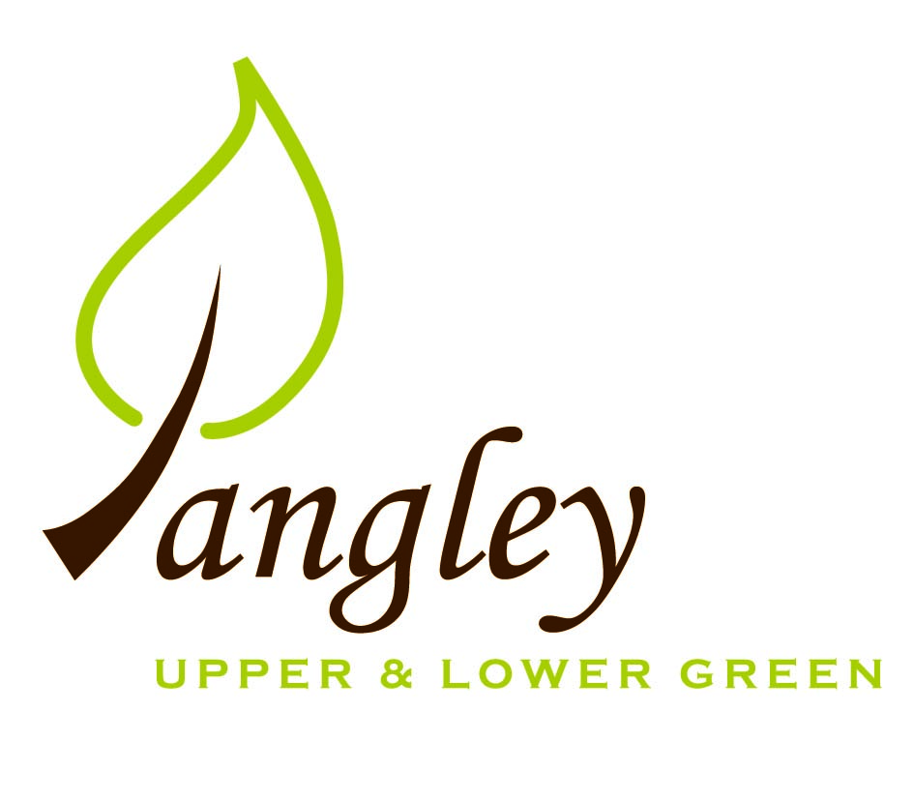

Clerk: Erica Williams
E-mail: langleyclerk@googlemail.com
13 Princes Close, Balsham, Cambridgeshire CB21 4EE

A MEETING OF LANGLEY PARISH COUNCIL
HELD AT LANGLEY COMMUNITY CENTRE ON
MONDAY 10th June 2024 at 8.00pm

MINUTES
Attended: Cllr Elkington (Chair), Cllr Anderson, Cllr Clark, Cllr George, Cllr Barnes.
Minutes: Erica Williams (Clerk)

1. APOLOGIES FOR ABSENCE
Cllr North, Cllr Smith.

2. DECLARATION OF INTERESTS
It was proposed and agreed by all that Langley Parish Council is the registered owner of the village green and Councillors declare general
interests in all agenda items relating to the village green. Any other interests would be declared in the usual way.
- Cllr Elkington: non-pecuniary, member of the Parish Council that owns the land on which the community centre is built.
- Cllr Anderson: non-pecuniary, member of the Parish Council that owns the land on which the community centre is built.
- Cllr Clark: non-pecuniary, member of the Parish Council that owns the land on which the community centre is built.
- Cllr George: non-pecuniary, member of the Parish Council that owns the land on which the community centre is built.
- Cllr Barnes: non-pecuniary, member of the Parish Council that owns the land on which the community centre is built. 6.2 Personal – neighbouring property

3. PUBLIC PARTICIPATION SESSION WITH RESPECT TO ITEMS ON THE AGENDA AND OTHER MATTERS THAT ARE OF MUTUAL INTEREST
3.1 One member of the public attended.

4. MINUTES OF THE LAST MEETING
4.1 Councillors were asked to review the Minutes of the Parish Council meeting held on Monday 13th May. All agreed and Chair signed them off.

5. FINANCIAL CLARIFICATION
5.1 Financial Report – Bank reconciliation as at 31st May, the current account balance was £22,172.69. PC unpresented payments, £3,466.25 resulting in a current account balance of £18,706.44. Broken down as follows: Playground H&S funds £239.37, Ditches funds £2,000.00, Speed sign funds £3,214.14; PC funds £13,252.93. PC deposit account £10,376.73.
5.2 All Cllrs reviewed and agreed BACS run.
Items 5.3 – 5.11 Year End Accounts
5.3 Year-end accounts (ending 31st March 2024), including Bank Reconciliation, Receipts and Payments and Analysis of Variances approved by Council and signed by Chair.
5.4 Internal Control Statement for Year Ending 31st March 2024. Approved by Council and signed by Chair.
5.5 Financial & Management Risk Assessment reviewed.
5.6 As neither the gross income nor gross expenditure exceeds £25,000 the PC are exempt from an external audit/limited assurance review;
5.7 Certificate of Exemption approved, dated and signed by RFO and Chair. Signed document to be submitted to PFK Littlejohns ASAP together with completed contact details form.
5.8 Internal Audit to be carried out w/c 10th June 2024.
5.9 Council reviewed and approved by resolution the Annual Governance Statement 2023/2024 signed and dated by RFO and Chair.
5.10 Council reviewed and approved by resolution the Accounting Statements 2023/2024 signed and dated by RFO and Chair.
5.11 Copies of the following documents to be published on website on Friday 14th June 2024.
a) completed certificate of exemption;
b) completed, signed and dated annual internal audit report;
c) completed, approved, dated and signed annual governance statement;
d) completed, approved, dated and signed summary accounting statements;
e) analysis of variances
f) bank reconciliation;
g) notice of the period for the exercise of public rights; Dates set as Friday 14th June to Thursday 25th July. Notice to be published on website and noticeboards on Thursday 13th June 2024.

6. PLANNING APPLICATIONS/PROPERTY
6.1 UTT/24/1359/FUL – Land West of Hill View, Langley Lower Green. NO OBJECTIONS.

7. LANGLEY VILLAGE PROJECT
7.1 Discussions ongoing as to the future of the Village Project and further meetings to be organised. Work has begun on the limestone wash at the Church.

8. LOCAL ENVIRONMENT
8.1 Grass cutting schedule ongoing. Cllrs to review Village Green grass cutting area at next PC meeting and define areas that are being cut.
8.2 Parishioner reported dead Willow tree on Common Land. PC to request quote from Crown Tree & Garden Care. Further tree work also required on Ash tree near to the playground.
8.3 PC await response from Highways following the receipt of ditch clearance programme of works.
8.4 Flashing speed signs. Small working party to take photographs and mark locations on map.
8.5 Clerk to request update from residents regarding the current status of improvement works to the track at the top of the green.
8.6 Lay-by parking – no update.
8.7 Cllrs discussed sports on the Village Green. To be reviewed at next PC meeting.

9. PLAYGROUND
9.1 Outstanding works now completed.

10. DISTRICT COUNCIL
Cllr Oliver provided an update to Cllrs and answered questions.

11. BACS PAYMENTS
11.1 Council agreed the following BACS payments to be made:

Langley Parish Council – BACS payments for June 2024
Clear Councils | Parish Council insurance renewal | BACS | £558.62
The Printworks | Village Voice printing | BACS | £77.00
Paul Abrahams | Tree work at the playground | BACS | £400.00
GWB Horticulture | Grass cutting | BACS | £1,596.00
RAS Handyman Services | Playground works | BACS | £460.00
Erica Williams | Clerks salary | BACS | £374.63
 |  | Total | £3,466.25
12. MATTERS TO BE RAISED BY MEMBERS FOR THE NEXT AGENDA
12.1 Resurfacing of Long Ley
12.2 Amendment to online banking signatory

13. DATE OF NEXT MEETING:
13.1 The next meeting will be on Monday 8th July 2024 at Langley Community Centre.

