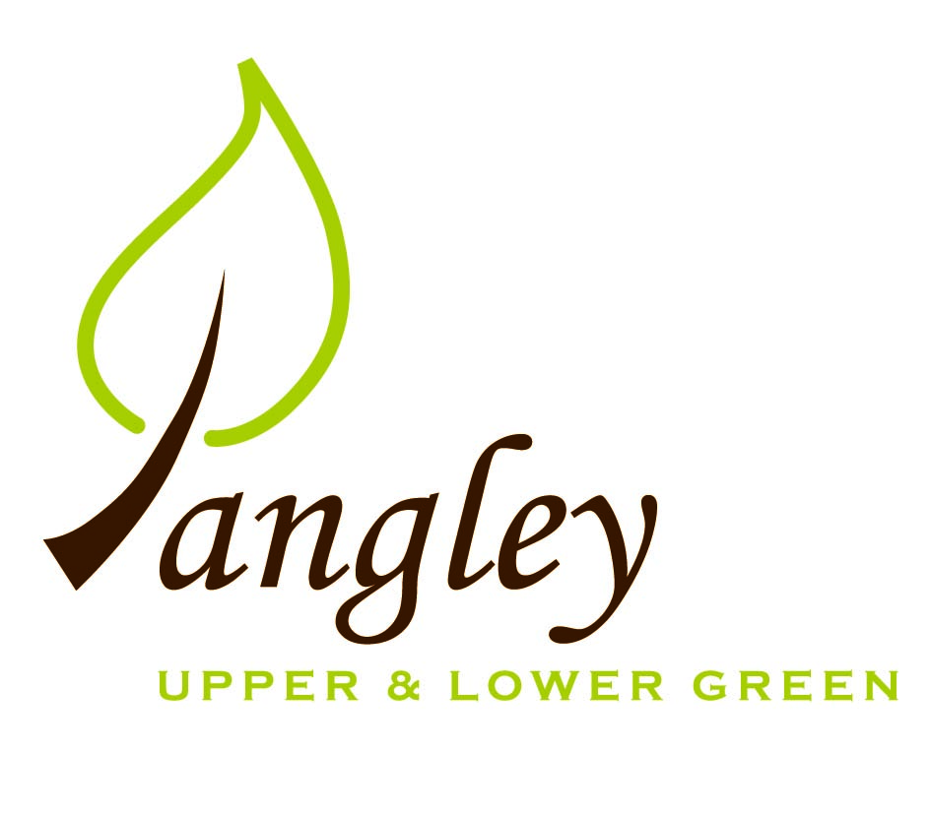

Clerk: Erica Williams
E-mail: langleyclerk@googlemail.com
13 Princes Close, Balsham, Cambridgeshire CB21 4EE

A MEETING OF LANGLEY PARISH COUNCIL
HELD AT LANGLEY COMMUNITY CENTRE ON
MONDAY 13th May 2024 at 8.00pm

MINUTES
Attended: Cllr Elkington (Chair), Cllr North (Vice-Chair), Cllr Smith, Cllr Anderson, Cllr Clark, Cllr George, Cllr Barnes.
Minutes: Erica Williams (Clerk)

1. APOLOGIES FOR ABSENCE
None.

2. DECLARATION OF INTERESTS
It was proposed and agreed by all that Langley Parish Council is the registered owner of the village green and Councillors declare general
interests in all agenda items relating to the village green. Any other interests would be declared in the usual way.
- Cllr Elkington: non-pecuniary, member of the Parish Council that owns the land on which the community centre is built.
- Cllr North: non-pecuniary, member of the Parish Council that owns the land on which the community centre is built.
- Cllr Smith: non-pecuniary, member of the Parish Council that owns the land on which the community centre is built.
- Cllr Anderson: non-pecuniary, member of the Parish Council that owns the land on which the community centre is built.
- Cllr Clark: non-pecuniary, member of the Parish Council that owns the land on which the community centre is built. 6.2; close business association with applicant.
- Cllr George: non-pecuniary, member of the Parish Council that owns the land on which the community centre is built. 6.2: personal, applicant.
- Cllr Barnes: non-pecuniary, member of the Parish Council that owns the land on which the community centre is built.

3. PUBLIC PARTICIPATION SESSION WITH RESPECT TO ITEMS ON THE AGENDA AND OTHER MATTERS THAT ARE OF MUTUAL INTEREST
3.1 One member of the public attended.

4. MINUTES OF THE LAST MEETING
4.1 Councillors were asked to review the Minutes of the Parish Council meeting held on Monday 8th April. All agreed and Chair signed them off.

5. FINANCIAL CLARIFICATION
5.1 Financial Report – Bank reconciliation as at 30th April, the current account balance was £22,583.78 (1st precept payment received of £8,500.00). PC unpresented payments, £519.44 resulting in a current account balance of £22,064.34. Broken down as follows: Playground H&S funds £699.37, Ditches funds £2,000.00, Playground funds £3,214.14; PC funds £16,150.83. PC deposit account £10,376.73.
5.2 All Cllrs reviewed and agreed BACS run.
5.3 Clerk provided Cllrs with quotes for insurance renewal. Clear Councils renewal £558.62. Zurich quoted £599.00. Cllr Elkington proposed to renew Clear Council policy, Cllr North seconded. All agreed.

6. PLANNING APPLICATIONS/PROPERTY
6.1 UTT/24/1037/FUL – Laburnham House, Langley Upper Green – No comments.
6.2 UTT/23/0915/FUL (Planning appeal) – Hall Farm, Langley Upper Green – Cllr George left the room during the discussion. The PC wish to support this application due to the inevitable loss or collapse of the Historic curtilage of the building should it not be preserved.

7. LANGLEY VILLAGE PROJECT
7.1 Village Project now drawing to a close in terms of funding. Meeting to be held to discuss how best to move forward with future projects.

8. LOCAL ENVIRONMENT
8.1 Grass cutting schedule ongoing. Clerk to chase GWB for cuts around Potterills railings.
8.2 Ditch clearance programme – Cllr George provided the PC with a very comprehensive report on waterway clearance and flood reduction plan. Clerk to send to Cllr Gadd and Essex Highways for their comments.
8.3 Cllrs to check locations for portable speed signs and measure verges to meet regulations. The PC cannot apply for Community Safety funding as grant cannot be spent on the purchase of new equipment. Cllrs agreed to ringfence money previously set aside for new playground equipment to fund the purchase of portable speed signs.
8.4 Documentation has now been received from Rural Affordable Housing for residents to complete housing survey. Cllrs to hand deliver to every household.
8.5 International Tribute D-Day – Beacon Event to be held on Thursday 6th June. All to assemble on Village Green at 8.45pm for lighting of the Beacon at 9.15pm. Family picnic event on Saturday 8th June.
8.6 Clerk confirmed that Cllr training dates have now been booked.
8.7 The PC wish to nominate the Community Centre for a Community Award and will pass details to the CC Committee.
8.8 Annual Meeting of the Parish confirmed for Wednesday 22nd May at 8pm.
8.9 Cllr Elkington has met with the contractor repairing the track at the Village Green, who has agreed to remove the brick wall that was in the stages of being constructed, due to the fact that it can not be erected on Village Green.

9. PLAYGROUND
9.1 Quote has now been received for £400 from Paul Abrahams for cutting back the hedge along the field side of the playground.

10. DISTRICT COUNCIL
Cllr Oliver provided an update to Cllrs and answered questions.

11. BACS PAYMENTS
11.1 Council agreed the following BACS payments to be made:

Langley Parish Council – BACS payments for May 2024
London Hearts | Replacement defibrillator pads |  | £56.40
Sustainable Furniture | New bench for the Village Green (paid in April) |  | £260.00
Erica Williams | Clerks salary |  | £463.04
 |  | Total | £779.44
12. MATTERS TO BE RAISED BY MEMBERS FOR THE NEXT AGENDA
12.1 Lay-by car parking
12.2 Sports on the Green

13. DATE OF NEXT MEETING:
13.1 The next meeting will be on Monday 10th June 2024 at Langley Community Centre.

