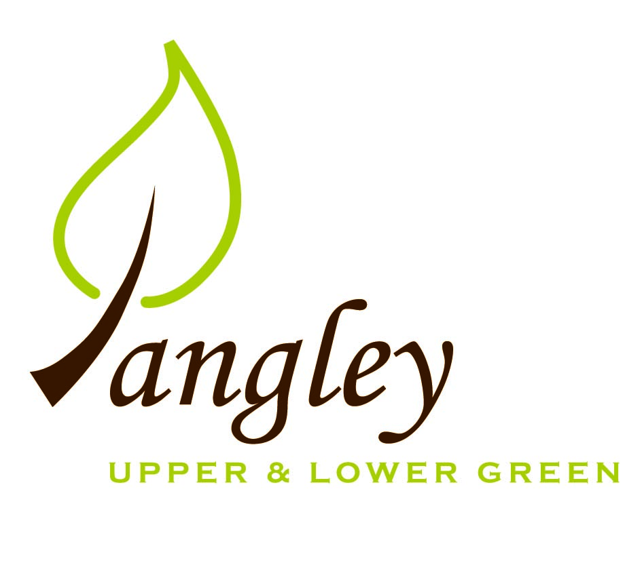

Clerk: Erica Williams
E-mail: langleyclerk@googlemail.com
13 Princes Close, Balsham, Cambridgeshire CB21 4EE

A MEETING OF LANGLEY PARISH COUNCIL
HELD AT LANGLEY COMMUNITY CENTRE ON
MONDAY 8th July 2024 at 8.00pm

MINUTES
Attended: Cllr Elkington (Chair), Cllr North, Cllr Anderson, Cllr Clark, Cllr George, Cllr Barnes. Cllr Smith.
Minutes: Erica Williams (Clerk)

1. APOLOGIES FOR ABSENCE
None.

2. DECLARATION OF INTERESTS
It was proposed and agreed by all that Langley Parish Council is the registered owner of the village green and Councillors declare general
interests in all agenda items relating to the village green. Any other interests would be declared in the usual way.
- Cllr Elkington: non-pecuniary, member of the Parish Council that owns the land on which the community centre is built.
- Cllr North: non-pecuniary, member of the Parish Council that owns the land on which the community centre is built.
- Cllr Smith: non-pecuniary, member of the Parish Council that owns the land on which the community centre is built.
- Cllr Anderson: non-pecuniary, member of the Parish Council that owns the land on which the community centre is built.
- Cllr Clark: non-pecuniary, member of the Parish Council that owns the land on which the community centre is built.
- Cllr George: non-pecuniary, member of the Parish Council that owns the land on which the community centre is built.
- Cllr Barnes: non-pecuniary, member of the Parish Council that owns the land on which the community centre is built.

3. PUBLIC PARTICIPATION SESSION WITH RESPECT TO ITEMS ON THE AGENDA AND OTHER MATTERS THAT ARE OF MUTUAL INTEREST
3.1 No members of the public attended.

4. MINUTES OF THE LAST MEETING
4.1 Councillors were asked to review the Minutes of the Parish Council meeting held on Monday 10th June. All agreed and Chair signed them off.

5. FINANCIAL CLARIFICATION
5.1 Financial Report – Bank reconciliation as at 30th June, the current account balance was £18,953.45. PC unpresented payments, £1,392.63 resulting in a current account balance of £17,560.82. Broken down as follows: Playground H&S funds £239.37, Ditches funds £2,000.00, Speed sign funds £3,214.14; PC funds £12,107.31. PC deposit account £10,447.87 (interest received of £71.14).
5.2 All Cllrs reviewed and agreed BACS run.
5.3 Clerk reported that the PC had passed the Internal Audit, with a couple of minor recommendations to action. Full report to follow.

6. PLANNING APPLICATIONS/PROPERTY
6.1 None received.

7. LANGLEY VILLAGE PROJECT
7.1 Report received from parishioner regarding the status of the Village Project. Discussions around the future of the project ongoing.

8. LOCAL ENVIRONMENT
8.1 Grass cutting schedule ongoing and extra cuts to take place in the lead up to the Fete. Cllrs discussed invoice received for servicing works to the community centre lawnmower, which is used to cut the area directly around the community centre. Grant request form to be completed and submitted to the PC. Clerk to action.
8.2 Parishioner reported dead Willow tree on Common Land. Quote received to both monolith and completely remove tree. Clerk to contact UK Power Networks and request a site visit as the branches are wrapped around electricity lines.
8.3 County Councillor, Paul Gadd, in conversation with Highways contact following the report produced by Cllr George regarding drains in the village. Pothole at the bottom of Waterwick Hill has been filled in poorly – Clerk to lodge official complaint. Cllr Clerk reported that the road at the top of Waterwick Hill is rising up. Clerk to log on portal.
8.4 Cllrs agreed that public money cannot be used to repair Common Land and Clerk to notify resident regarding damage near to their house.
8.5 Three potential sites identified for portable flashing speed signs.
Cllr Elkington proposed that the PC purchase one device. Cllr Clark seconded, all agreed. Clerk to complete paperwork and finalise quotes.
8.6 Track repair works in Upper Green still ongoing.
8.7 No obvious solution to the lay-by parking issue and discussions ongoing.
8.8 Sports on the Green – to be carried forward for discussion in September.
8.9 Cllr North has been in discussion with contractor regarding community bus transport. New contractor due to meet next weeks to confirm routes. Further updates to follow.

9. PLAYGROUND
9.1 Outstanding works now completed. No further update.

10. DISTRICT COUNCIL
Cllr Oliver provided an update to Cllrs and answered questions. Update received from Cllr Gadd.

11. BACS PAYMENTS
11.1 Council agreed the following BACS payments to be made:

Langley Parish Council – BACS payments for July 2024
LCC & ST | Hire of community centre | BACS | £138.00
EALC | Councillor training | BACS | £480.00
Erica Williams | Clerks salary | BACS | £374.63
 |  | Total | £992.63
12. MATTERS TO BE RAISED BY MEMBERS FOR THE NEXT AGENDA
12.1 Bin at the playground
12.2 Gov.uk email addresses
12.3 Withdrawal of landlines by BT
12.4 Noticeboard maintenance

13. DATE OF NEXT MEETING:
13.1 The next meeting will be on Monday 9th September 2024 at Langley Community Centre (no meeting during August).

