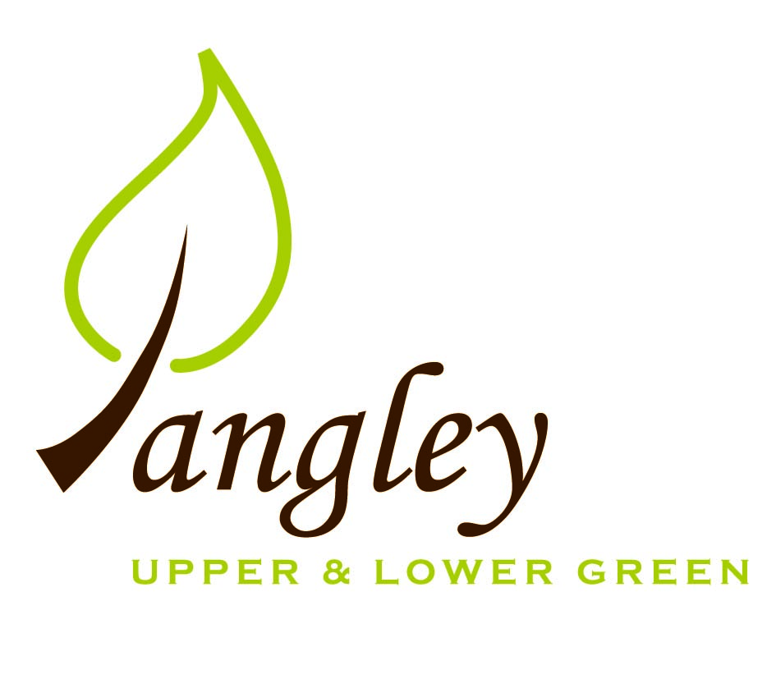

Clerk: Erica Williams
E-mail: langleyclerk@googlemail.com
13 Princes Close, Balsham, Cambridgeshire CB21 4EE

A MEETING OF LANGLEY PARISH COUNCIL
HELD AT LANGLEY COMMUNITY CENTRE ON
MONDAY 11^{h} November 2024 at 8.00pm

MINUTES
Attended: Cllr Elkington (Chair), Cllr Smith, Cllr George, Cllr Barnes, Cllr Anderson
Minutes: Erica Williams (Clerk)

1. APOLOGIES FOR ABSENCE
Cllr North, Cllr Clark

2. DECLARATION OF INTERESTS
It was proposed and agreed by all that Langley Parish Council is the registered owner of the village green and Councillors declare general
interests in all agenda items relating to the village green. Any other interests would be declared in the usual way.
- Cllr Elkington: non-pecuniary, member of the Parish Council that owns the land on which the community centre is built.
- Cllr Smith: non-pecuniary, member of the Parish Council that owns the land on which the community centre is built. 6.1 personal; neighbouring property to proposal.
- Cllr George: non-pecuniary, member of the Parish Council that owns the land on which the community centre is built. 6.3 financial interest, 6.2 personal; applicant.
- Cllr Barnes: non-pecuniary, member of the Parish Council that owns the land on which the community centre is built.
- Cllr Anderson: non-pecuniary, member of the Parish Council that owns the land on which the community centre is built. 6.2 personal; working for both parties, 6.3 employee of applicant.

3. PUBLIC PARTICIPATION SESSION WITH RESPECT TO ITEMS ON THE AGENDA AND OTHER MATTERS THAT ARE OF MUTUAL INTEREST
3.1 One member of the public attended.

4. MINUTES OF THE LAST MEETING
4.1 Councillors were asked to review the Minutes of the Parish Council meeting held on Monday 14th October. All agreed and Chair signed them off.

4a. LOW COST HOUSING
4a.1 RCCE gave a presentation to the PC, reporting the findings of the recent survey and Cllrs were able to ask questions. Next steps are to write to residents summarising the findings and be matched with a rural housing provider.

5. FINANCIAL CLARIFICATION
5.1 Financial Report – Bank reconciliation as at 31st October, the current account balance was £24,173.10. PC unpresented payments, £511.34 resulting in a current account balance of £23,661.76. Broken down as follows: Playground H&S funds £239.37, Ditches funds £2,000.00, Speed sign funds £3,214.14; PC funds £18,208.25. PC deposit account £10,520.29.
5.2 All Cllrs reviewed and agreed BACS run.
5.3 Clerk presented the PC with options regarding moving to a gov.uk domain. Next steps are to get detailed quotes from three registrars.
5.5 The Parish Council have received a request to accept a privately purchased scythe mower onto it’s asset register. Cllrs voted unanimously to reject the proposal. However, the PC have previously agreed to cover an annual service cost only to the value of £120 plus VAT on a grant basis.
5.6 Clerk has requested quote for noticeboard maintenance.

6. PLANNING APPLICATIONS/PROPERTY
6.1 UTT/24/2788/FUL Land rear of Sparrows, Langley Upper Green – OBJECTIONS – Very tight onto visually restricted road. Driveways on either side of the proposed roadway. Access still very tight.
6.2 UTT/24/2538/FUL (also UTT/24/2539/LB) Barns at Hall Farm, The Causeway – NO OBJECTIONS. Clerk to reiterate previous support comments.
6.3 UTT/24/1710/PAQ3 (Appeal) Barn at Langley Lawn, Langley Lower Green – NO OBJECTIONS
6.4 UTT/24/2558/HHF Hickmans, Upper Green Road – INCOMPLETE APPLICATON. No plans attached to the application, therefore the PC are unable to make comment.

7. LANGLEY VILLAGE PROJECT
7.1 Church have sold 8 pews so there is now more floor space. Re-painting complete. Porch needs some work. Waiting for works to be carried out so that the re-ordering project can be completed.

8. LOCAL ENVIRONMENT
8.1 Grass cutting contract expires in March 2025. Tender packs have been sent out with a deadline of Monday 6th January 2025.
8.2 The PC are still awaiting the removal of dead ash trees by contractor. Further quotes required for an ash tree near to Bury Farm and for pond clearance near to Hurdles. Cllr Smith to begin planting the young Oak tree donated by parishioner. Proposal by Cllr Elkington to purchase metal tree guard to protect this at a cost of £100. Cllr Barnes seconded. All agreed. Clerk to action.
Cllr Smith has produced a very comprehensive report numbering all trees in the village to be able to moniter ongoing works.
8.3 Following Cllr George’s ditch clearance works with Essex Highways, next steps are to send letter to identified landowners requesting ditch clearance. Confirmation received of Bull Lane jetting on 25th November.
8.4 Further updates to follow on speed signs once permission from Highways has been granted.
8.5 Disconnection of power to phone box in Upper Green was due to take place on 8th November. Clerk awaiting confirmation paperwork.
8.6 Cllrs agreed job roles for the PC website and Clerk to begin updating this.
8.7 The PC approved a request to purchase a christmas tree for the Green and a cost of £120 plus VAT.
8.7 Cllrs discussed an email received from a resident regarding resurfacing works which are due to commence shortly in Long Ley and will continue to moniter the situation.

10. DISTRICT & COUNTY COUNCIL
Cllr Oliver provided an update to Cllrs and answered questions.

11. BACS PAYMENTS
11.1 Council agreed the following BACS payments to be made:

Langley Parish Council – BACS payments for November 2024
Erica Williams | Clerks salary (to include backdated pay award) | BACS | £511.34
 |  | Total | £511.34
12. MATTERS TO BE RAISED BY MEMBERS FOR THE NEXT AGENDA
12.1 Robot grass cutting
12.2 Steamwatch
12.3 Precept

13. DATE OF NEXT MEETING:
13.1 The next meeting will be on Monday 13th January 2025 at Langley Community Centre.

