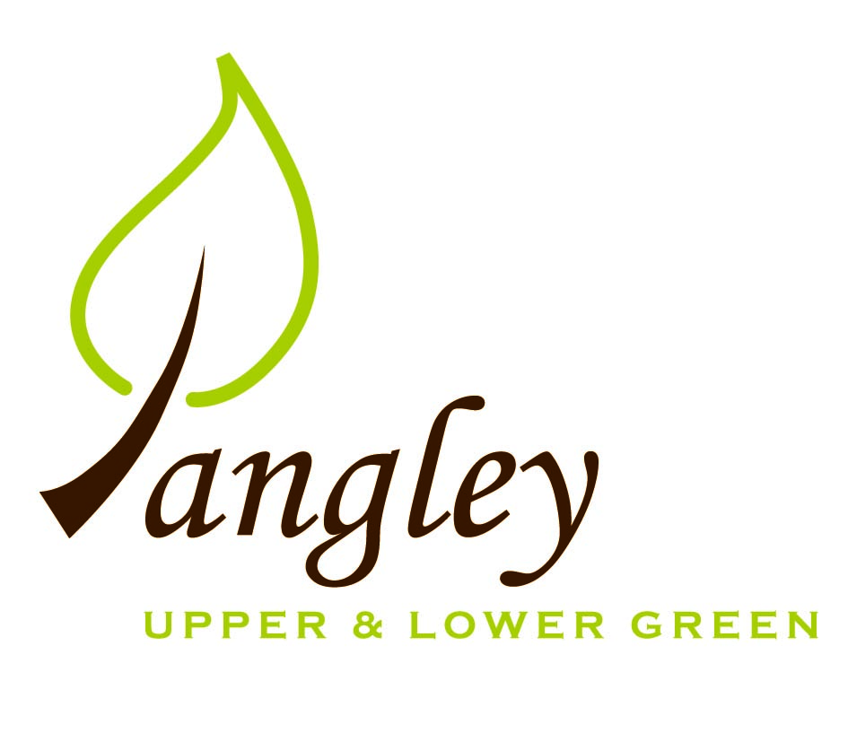

Clerk: Erica Williams
E-mail: langleyclerk@googlemail.com
13 Princes Close, Balsham, Cambridgeshire CB21 4EE

A MEETING OF LANGLEY PARISH COUNCIL
HELD AT LANGLEY COMMUNITY CENTRE ON
WEDNESDAY 10th May 2023 at 8.00pm

MINUTES
Attended: Cllr Elkington (Chair), Cllr Barnes, Cllr Clark
Minutes: Erica Williams (Clerk)

1. APOLOGIES FOR ABSENCE
Cllr Joplin absent.
Cllr North and Cllr Smith apologies received ahead of the meeting.

2. DECLARATION OF INTERESTS
It was proposed and agreed by all that Langley Parish Council is the registered owner of the village green and Councillors declare general
interests in all agenda items relating to the village green. Any other interests would be declared in the usual way.
- Cllr Elkington: 8.1, non-pecuniary, member of the Parish Council that owns the land on which the community centre is built.
- Cllr Barnes: 8.1, non-pecuniary, member of the Parish Council that owns the land on which the community centre is built.
- Cllr Clark: 8.1, non-pecuniary, member of the Parish Council that owns the land on which the community centre is built. 7.2, personal, Hall Farm due to close working relationship with applicant and Langley Lawn due to being the applicant.

3. PUBLIC PARTICIPATION SESSION WITH RESPECT TO ITEMS ON THE AGENDA AND OTHER MATTERS THAT ARE OF MUTUAL INTEREST
3.1 One member of the public attended.

4. MINUTES OF THE LAST MEETING
4.1 Councillors were asked to review the Minutes of the Parish Council meeting held on Tuesday 11th April. All agreed and Chair signed them off.

6. FINANCIAL CLARIFICATION
6.1 Financial Report – Bank reconciliation as at 30th April, the current account balance was £26,988.66 (Locality Fund grant of £908.62 and first precept payment of £8,035.00). PC unpresented payments, £810.80 resulting in a current account balance of £26,177.86. Broken down as follows: Playground H&S funds £3,000.00, Ditches funds £2,000.00, Playground funds £3,214.14 (inclusion of Locality Fund grant); PC funds £17,963.72. PC deposit account £10,109.15.
6.2 All Cllrs reviewed and agreed BACS run.
6.3 Clerk has received renewal notice from BHIB for PC insurance, for £467.67. Further quote obtained from Zurich for £599.00 and third quote requested from CAS Ltd, but not yet received. This figure is expected to be higher and after discussion, the PC opted to accept the renewal figure from BHIB. Clerk to complete paperwork.
6.4 Coronation grant from UDC confirmed for £600.00. Clerk to claim when all receipts have been received.

7. PLANNING APPLICATIONS/PROPERTY
7.1 Decisions:
UTT/23/0077/HHF – 1 The Kangels, Langley Upper Green – APPROVED
UTT/23/0420/FUL (and LB) – The Bull, Langley Lower Green - AWAITING DECISION
UTT/23/0650/HHF – New Farm, Waterwick Hill – AWAITING DECISION
7.2 Applications:
UTT/23/0915/FUL Hall Farm Upper Green Langley
UTT/23/1030/FUL Langley Lawn Langley Lower Green
Due to Cllr Clark declaring an interest in both applications, and only two other Councillors present at the meeting, the PC were no longer quorate. Therefore, an extraordinary PC meeting have been called for Wednesday 17th May at 8pm to discuss the above applications.

8. LANGLEY VILLAGE PROJECT
8.1 Village project ongoing and fundraising continuing. Maintenance work has started on Langley Church and plans should be drawn up by the end of May.

10. LOCAL ENVIRONMENT
10.1 Trees / Verges / Grass cutting – Still waiting for quotes for tree and ditch work. Tree work likely to commence in the Autumn now. The PC discussed identifying dead/dying trees in the Parish to prioritise future work. Clerk to contact GWB about strimming around Potterills railings.
10.2 Cllr Smith to action tree guard removals upon his return and seek to remove, inspect and re-purpose where appropriate.
10.3 Annual Parish Meeting on 31st May at 8pm. Poster has gone to all households in the village.
10.5 Following discussions, Clerk to approach Hundred Parishes Society to see if there are any extensions to the deadline for grant funding.
10.6 Cllrs Elkington and Clark to attend UDC Parish Planning training.
10.7 The PC are very grateful to a parishioner who has agreed to replace the Elephant Bench on the Green. PC to pay for materials.
10.8 Clerk has received correct quote from UK Power Networks to disconnect the electricity supply to the phone box. Clerk to request discount as recompense for time taken and expenses incurred thus far.
10.9 Further discussion needed to identify possible community projects.
10.10 Elections paperwork to be completed and returned. Clerk to post notice of vacancy of Councillor.

11. PLAYGROUND
11.1 No updated.
11.2 Contractor has carried out initial visit to quote for maintenance work. Clerk to organise another site meeting to finalise this.

12. COUNTY COUNCIL
No report provided this month.

13. CHEQUES FOR SIGNING
13.1 Council agreed the following BACS payments to be made:

Langley Parish Council – BACS payments for May 2023
Dash UK Ltd | Coronation mugs (paid in April 23) |  | £298.80
Print Juice | Coronation posters |  | £45.00
Erica Williams | Clerks salary |  | £343.64
Catherine Andrews | Reimbursement for Coronation costs |  | £33.16
 |  | Total | £720.60
14. MATTERS TO BE RAISED BY MEMBERS FOR THE NEXT AGENDA
14.1 Please note that no decisions can lawfully be made under this item. LGA 1972, Section 12 10(2)(b) states that business must be specified; therefore, the Council cannot lawfully raise matters for decision.

15. DATE OF NEXT MEETING:
15.1 The next meeting will be on Monday 12th June at Langley Community Centre.

