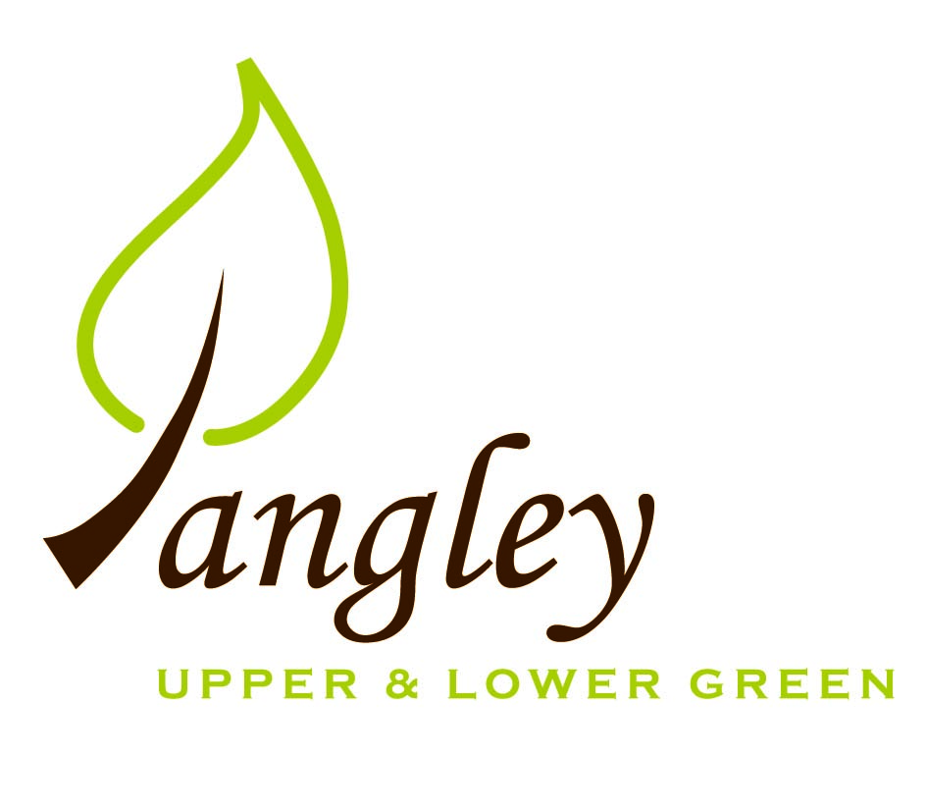

Clerk: Erica Williams
E-mail: langleyclerk@googlemail.com
13 Princes Close, Balsham, Cambridgeshire CB21 4EE

A MEETING OF LANGLEY PARISH COUNCIL
HELD AT LANGLEY COMMUNITY CENTRE ON
MONDAY 12th June 2023 at 8.00pm

MINUTES
Attended: Cllr Elkington (Chair), Cllr North (Vice-Chair), Cllr Joplin, Cllr Barnes, Cllr Clark. Cllr Oliver (UDC) arrived at 8.35pm
Minutes: Erica Williams (Clerk)

1. APOLOGIES FOR ABSENCE
Cllr Smith apologies received ahead of the meeting.

2. DECLARATION OF INTERESTS
It was proposed and agreed by all that Langley Parish Council is the registered owner of the village green and Councillors declare general
interests in all agenda items relating to the village green. Any other interests would be declared in the usual way.
- Cllr Elkington: 8.1, non-pecuniary, member of the Parish Council that owns the land on which the community centre is built.
- Cllr Barnes: 8.1, non-pecuniary, member of the Parish Council that owns the land on which the community centre is built.
- Cllr North: 8.1, non-pecuniary, member of the Parish Council that owns the land on which the community centre is built.
- Cllr Joplin: 8.1, non-pecuniary, member of the Parish Council that owns the land on which the community centre is built.
- Cllr Clark: 8.1, non-pecuniary, member of the Parish Council that owns the land on which the community centre is built. 7.1, personal, Cllr Clark is applicant.

3. PUBLIC PARTICIPATION SESSION WITH RESPECT TO ITEMS ON THE AGENDA AND OTHER MATTERS THAT ARE OF MUTUAL INTEREST
3.1 Three members of the public attended.

4. MINUTES OF THE LAST MEETING
4.1 Councillors were asked to review the Minutes of the Parish Council meetings held on Wednesday 10th May and the extraordinary meeting held on Wednesday 17th May. All agreed and Chair signed them off.

6. FINANCIAL CLARIFICATION
6.1 Financial Report – Bank reconciliation as at 31st May, the current account balance was £26,507.47. PC unpresented payments, £2,290.92 resulting in a current account balance of £24,216.55. Broken down as follows: Playground H&S funds £3,000.00, Ditches funds £2,000.00, Playground funds £3,214.14; PC funds £16,002.41. PC deposit account £10,109.15.
6.2 All Cllrs reviewed and agreed BACS run. Clerk notified Cllrs that invoices had come in from Jane Kidd (for Year End), Taylor Bradshaw (for Internal Audit) and Cllr North (for reimbursement of signage for the playground) and that these would be included in June payment run.
6.3 Clerk has received quote from contractor for playground maintenance work, which Cllrs approved. Clerk to instruct contractor to commence work.
Items 6.4 – 6.12 presented to the Council by Jane Kidd
6.4 Year-end accounts (ending 31st March 2023), including Bank Reconciliation, Receipts and Payments and Analysis of Variances to be approved by Council and signed by Chair.
6.5 Internal Control Statement for Year Ending 31st March 2023. Approved by Council and signed by Chair.
6.6 Financial & Management Risk Assessment last reviewed in May 2022 to be reviewed again in May 2023.
6.7 As neither the gross income nor gross expenditure exceeds £25,000 the PC are exempt from an external audit/limited assurance review;
6.8 Certificate of Exemption approved, dated and signed by RFO and Chair. Signed document to be submitted to PFK Littlejohns ASAP together with completed contact details form.
6.9 Internal Audit (carried out by Tayler Bradshaw) was completed and approved.
6.10 Council reviewed and approved by resolution the Annual Governance Statement 2022/2023 and signed and dated by RFO and Chair.
6.11 Council reviewed and approved by resolution the Accounting Statements 2022/2023 and signed and dated by RFO and Chair.
6.12 Copies of the following documents to be published on website on Monday 19th June 2023.
a) completed certificate of exemption;
b) completed, signed and dated annual internal audit report;
c) completed, approved, dated and signed annual governance statement;
d) completed, approved, dated and signed summary accounting statements;
e) analysis of variances
f) bank reconciliation;
g) notice of the period for the exercise of public rights; Dates set as Monday 19th June to Friday 28th July. Notice to be published on website and noticeboards on Friday 16th June 2023.

7. PLANNING APPLICATIONS/PROPERTY
7.1 Applications:
UTT/23/1243/HHF Herons Rest, Upper Green Road – NO OBJECTIONS
UTT/23/1216/HHF Duddenhoe Grange, Upper Green Road – NO OBJECTIONS
UTT/23/1399/FUL Langley Lawn, Langley Lower Green (Cllr Clark left the room whilst discussions were ongoing) – NO OBJECTIONS

8. LANGLEY VILLAGE PROJECT
8.1 Church plans have been submitted to the Diocese for the first phase (kitchen work). Friends of Langley Church have paid for some maintenance work that has been carried out. Fundraisers planned include Ladies Day lunch and Midsummer BBQ.

10. LOCAL ENVIRONMENT
10.1 Trees / Verges / Grass cutting – Grass cutting schedule needs addressing to alleviate multiple visits.
10.2 Cllr Elkington updated Cllrs on the Parish Planning training and circulated slides for information.
10.3 Two parishioners spoke to Cllrs about Rural Affordable Housing schemes. Following discussion the PC will explore this in greater detail and seek to invite RCCE to the July meeting to present further ideas.
10.4 Community projects ongoing. No further updates.
10.5 Following discussions, the PC will explain to hirers that have a marquee, that music must end at 11.30pm, in line with the CC rules.
10.6 The PC do not have provision for Salt Bag storage or distribution so will not be taking this further.

11. PLAYGROUND
11.1 No updates.
11.2 Contractor has provided quote and Clerk will instruct work to include new fencing, repair to the slide platform, matting and various other maintenance requirements.

12. DISTRICT COUNCIL
Cllr Oliver’s report was distributed prior to the meeting and Cllr Oliver answered questions on this from Cllrs.

13. CHEQUES FOR SIGNING
13.1 Council agreed the following BACS payments to be made:

Langley Parish Council – BACS payments for June 2023
Sue Smith | Reimbursement for Coronation costs (paid prior to meeting) |  | £48.03
BHIB | Parish Council insurance renewal |  | £467.67
JK Bookkeeping | Preparation of Year End Accounts |  | £150.00
Taylor Bradshaw | Internal Audit |  | £180.00
Cllr Mike North | Reimbursement for playground sign |  | £12.68
Erica Williams | Clerks salary |  | £443.05
UK Power Networks | Disconnection of electricity supply |  | £991.20
 |  | Total | £2,292.63
14. MATTERS TO BE RAISED BY MEMBERS FOR THE NEXT AGENDA
14.1 Please note that no decisions can lawfully be made under this item. LGA 1972, Section 12 10(2)(b) states that business must be specified; therefore, the Council cannot lawfully raise matters for decision.

15. DATE OF NEXT MEETING:
15.1 The next meeting will be on Monday 10th July at Langley Community Centre.

